SEG Awards Level 1

Award in Motor Vehicle Studies - 500/4242/7

Certificate in Motor Vehicle Studies - 500/4220/8

Diploma in Motor Vehicle Studies - 500/4209/9

Learner Assessment Record Book

Learners Name
SEG Awards Registration Number
Centre Name
Assessor 1 Name
Assessor 2 Name

DECLARATION OF AUTHENTICITY

This declaration must be completed and signed by the learner and countersigned
by the tutor / assessor and covers all evidence submitted for moderation.

Learner Name
Unique Learner Number (ULN) |  | SEG  Learner Reg. ID
Qualification Title
Centre Name

Learner statement of authenticity

Before signing please read the guidance below.

I confirm that the attached assignment / portfolio is all my own work and does not include any work completed by anyone other than myself. I have completed the assignment / portfolio in accordance with SEG Awards’ instructions and within the time limits set by my centre.

Signature |  | Date

Centre confirmation of authenticity

On behalf of …………………………………….(insert centre name), I confirm that the above mentioned learner, to the best of my knowledge, is the sole author of the completed assignment / portfolio attached, and the assessments have been completed under the required conditions.

Signed |  | Date
Name
Title

Guidance for Learners

You have been asked to sign this Declaration of Authenticity and place it at the front of your portfolio or course work assessment. It confirms that the work you have submitted for assessment is your own and that you have not copied it from someone else or allowed another learner to copy it from you.

When preparing any course work it is good practice to undertake research using information from published sources. If you quote directly from these sources then this must be indicated in your work by using quotation marks and referencing the document from which the quotation was taken. You must then comment in your own words on any ideas expressed.

Assessors, internal verifiers and SEG Awards’ external moderators and verifiers are subject specialists who can spot the use of published materials that may be passed as your own words or ideas.

If you do copy words from a published source and do not indicate their reference you will be committing plagiarism. This is considered a form of cheating and may result in your assessment being declared void.

SEG Awards Level 1 Award/Certificate/Diploma in Motor Vehicle Studies
Individual Learning Plan
LEARNERS NAME |  |  |  |  | ASSESSOR/S NAME/S
COURSE START DATE |  |  | COURSE WEEKLY HOURS |  |  |  | TOTAL COURSE HOURS
No. | UNIT TITLE |  |  | CREDIT  VALUE | AWARD | CERT |  | DIP | DATE  STARTED | DATE  COMPLETED
1 | Health and Safety for Motor Vehicle Studies H/501/7005 |  |  | 4
2 | Introduction to Engineering Equipment and Materials A/501/7009 |  |  | 4
3 | Introduction to Compression Ignition Power Units M/501/7010 |  |  | 4
4 | Introduction to Spark Ignition Power Units T/501/7011 |  |  | 4
5 | Introduction to Engine Liquid Cooling and Engine Lubrication Systems A/501/7012 |  |  | 4
6 | Introduction to Spark Ignition and Compression Ignition Fuel Systems F/501/7013 |  |  | 4
7 | Introduction to Vehicle Transmission Systems J/501/7014 |  |  | 4
8 | Introduction to Battery and Lighting Systems L/501/7015 |  |  | 4
9 | Introduction to Steering and Suspension R/501/7016 |  |  | 4
10 | Introduction to Vehicle Braking Systems Y/501/7017 |  |  | 4
11 | Introduction to Vehicle Inspection D/501/7018 |  |  | 4
12 | Introduction to Vehicle Body Repair H/501/7019 |  |  | 4
13 | Introduction to Vehicle Refinishing Y/501/7020 |  |  | 4
14 | Introduction to Customer Care D/501/7021 |  |  | 1
15 | Introduction to Vehicle Wheels and Tyres H/501/7022 |  |  | 2
16 | Introduction to Vehicle Exhaust Systems M/51/7024 |  |  | 2
17 | Introduction to Vehicle ignition Systems A/501/7026 |  |  | 2
18 | Introduction to Vehicle Valeting J/501/7028 |  |  | 4
19 | Introduction to Motorcycle Maintenance L/501/70129 |  |  | 4
Total credits

SUMMARY OF ACHIEVEMENT RECORD

QUALIFICATION CLAIMED | FULL AWARD  (TICK) | FULL CERTIFICATE  (TICK | FULL DIPLOMA  (TICK) | UNITS OF CREDIT  (TICK)

No | Unit Title | Achieved | Learner |  |  | Tutor |  |  | Internal moderator |  |  | External Moderator
No | Unit Title | Achieved | Signature | Date | Signature |  | Date | Signature |  | Date | Signature |  | Date
01 | Health and Safety for Motor Vehicle Studies H/501/7005
02 | Introduction to Engineering Equipment and Materials A/501/7009
03 | Introduction to Compression Ignition Power Units M/501/7010
04 | Introduction to Spark Ignition Power Units T/501/7011
05 | Introduction to Engine Liquid Cooling and Engine Lubrication Systems A/501/7012
06 | Introduction to Spark Ignition and Compression Ignition Fuel Systems F/501/7013
07 | Introduction to Vehicle Transmission Systems J/501/7014
08 | Introduction to Battery and Lighting Systems L/501/7015
09 | Introduction to Steering and Suspension  R/501/7016
10 | Introduction to Vehicle Braking Systems  Y/501/7017
11 | Introduction to Vehicle Inspection  D/501/7018
12 | Introduction to Vehicle Body Repair  H/501/7019
13 | Introduction to Vehicle Refinishing  Y/501/7020
14 | Introduction to Customer Care  D/501/7021
15 | Introduction to Vehicle Wheels and Tyres  H/501/7022
16 | Introduction to Vehicle Exhaust Systems  M/501/7024
17 | Introduction to Vehicle Ignition Systems  A/501/7026
18 | Introduction to Vehicle Valeting  J/501/7028
19 | Introduction to Motorcycle Maintenance  L/501/70129

UNIT 01 (H/501/7005)

HEALTH AND SAFETY FOR MOTOR VEHICLE STUDIES

ASSESSMENT CRITERIA RECORD

Specification Reference | Assessment  Criteria | Evidence  Reference*
1.1 | Identify personal responsibilities and the responsibilities of others in the working environment | 1.1
1.2 | Identify and use correctly, equipment and procedures provided for Health and Safety in the workplace. | All Jobcards
1.3 | Demonstrate good housekeeping routines in the working environment | All Jobcards
2.1 | Select and use correct Personal Protective Equipment | All Jobcards
3.1 | Identify 4 Substances Hazardous to Health according to current regulations | 1.7
3.2 | Demonstrate appropriate ways to dispose of waste products in accordance with environmental guidance. | 1.7
4.1 | Know the principles of safe Manual Handling | 1.6
4.2 | Demonstrate safe Manual Handling using appropriate equipment | 1.6
5.1 | Identify the principles of fire prevention | 1.5
5.2 | Identify the type and location of fire extinguisher(s) in the working area | 1.2  1.4
5.3 | State the procedure to follow in the event of an emergency evacuation | 1.3

*Where evidence is provided through responses to underpinning knowledge tests, a copy of the responses must be included as part of the evidence. An evidence reference should be added to the column. The questions used should be included with the documentation and samples for the moderator.

ASSESSOR FEEDBACK ON UNIT COMPLETION
This confirms unit completion and should offer supportive guidance to the learner

Unit 01 (H/501/7005) |  | Assessment Criteria 1.1 | Task No 1.1

Task: Identify Health and Safety Duties

The basis of British Health and Safety Law is the Health and Safety at Work Act 1974.
This sets out general duties that employers and employees have to ensure safety in the work environment.

Complete the table below by identifying who is responsible for the duties listed:

Duty | Persons Responsible
 | Employer | Employee | All Personnel
Using personal Protective Equipment
Safety Training
Cleaning up oil spills
Repairing faulty airline
Supplying Personal Protective Equipment
Keeping work area clean and tidy
Provide First Aid facilities
Follow safety instructions

Assessor Checklist | Achieved  Y/N
Correct persons identified

Assessor Declaration
In signing this sheet the assessor and learner confirm that all the operations in this task were carried out by the named learner and the learner observed safe working practices at all times.

Assessor Signature……………………………………………………............ Date………………………..

Learner Signature.………………………………………………………..……….. Date………………………..

 | Unit 01 (H/501/7005) | Assessment Criteria 5.2 | Task No 1.2

Task: Identify Workshop Equipment

Learner Instructions

- Draw a plan of the workshop in the space below.
- On the plan identify the following
- Entrances and Exits
- Emergency Exit
- Vehicle lifts
- Positions and types of Fire Extinguishers
- Washing facilities

Assessor Checklist | Achieved  Y/N
Plan is accurate
All items included

Assessor Declaration
In signing this sheet the assessor and learner confirm that all the operations in this task were carried out by the named learner and the learner observed safe working practices at all times.

Assessor Signature……………………………………………………............ Date………………………..

Learner Signature.………………………………………………………..……….. Date………………………..

 | Unit 01 (H/501/7005) | Assessment Criteria 5.3 | Task No 1.3

Task: Emergency Evacuation Procedure

Learner Instructions

Every workplace will have an emergency evacuation procedure and it is important that you know the correct procedure for your workshop.
By inspecting the notices in the workshop, or other means, outline below what you should do in the case of an emergency evacuation
--------------------------------------------------------------------------------------------------------------------------------------------------------------------------------------------------------------------------------------------------------------------------------------------------------------------------------------------------------------------------------------------------------------------------------------------------------------------------------------------------------------------------------------------------------------------------------------------------------------------------------------------------------------------------------------------------------------------------------------------------------
--------------------------------------------------------------------------------------------------------------------------------------------------------------------------------------------------------------------------------------------------------------------------------------------------------------------------------------------------------------------------------------------------------------------------------------------------------------------------------------------------------------------------------------------------------------------------------------------------------------------------------------------------------------------------------------------------------------------------------------------------------
--------------------------------------------------------------------------------------------------------------------------------------------------------------------------------------------------------------------------------------------------------------------------------------------------------------------------------------------------------------------------------------------------------------------------------------------------------------------------------------------------------------------------------------------------------------------------------------------------------------------------------------------------------------------------------------------------------------------------------------------------------
----------------------------------------------------------------------------------------------------------------------------------------------------------------------------------------------------------------------------------------------------------------------------------------------------------------------------------------------------------------------------

Assessor Checklist | Achieved  Y/N
Procedure is accurate
All items included

Assessor Declaration
In signing this sheet the assessor and learner confirm that all the operations in this task were carried out by the named learner and the learner observed safe working practices at all times.

Assessor Signature……………………………………………………............ Date………………………..

Learner Signature.………………………………………………………..……….. Date………………………..

Unit 01 (H/501/7005) | Assessment Criteria 5.2 | Task No 1.4

Task: Identify Fire Extinguishers

Learner Instructions

In Task: 1.1, you identified the positions of the fire extinguishers in your workshop, but all extinguishers are not the same and are made for different types of fire.

- Investigate the fire extinguishers in your workshop and complete the diagram below by indicating the type of extinguisher suitable for each type of fire.

The first one has been completed to help you.
TYPE OF FIRE | 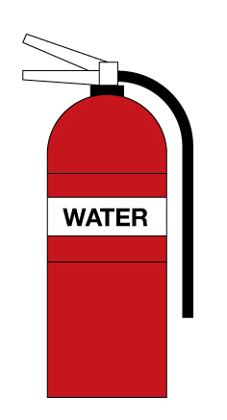 | 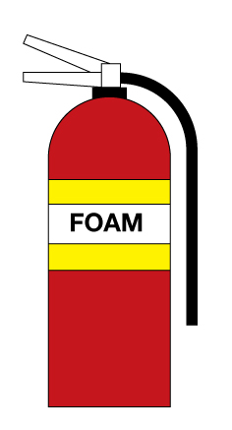 | 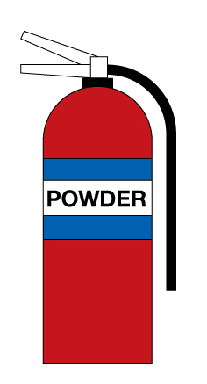 | 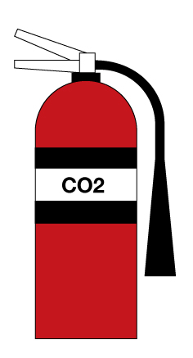
Type A
Paper, Wood, Textile and Fabric
Type B
Flammable Liquids
Type C
Flammable gases
Type E
Electrical Equipment

Assessor Checklist | Achieved  Y/N
Correct Extinguishers identified
All items included

Assessor Declaration
In signing this sheet the assessor and learner confirm that all the operations in this task were carried out by the named learner and the learner observed safe working practices at all times.

Assessor Signature……………………………………………………............ Date………………………..

Learner Signature.………………………………………………………..……….. Date………………………..

Unit 01 (H/501/7005) | Assessment Criteria 5.1 | Task No 1.5

Task: Principles of Fire Prevention

Learner Instructions

The best way of dealing with a fire in the workshop is to prevent it occurring in the first place.
In your workshop there will be many steps taken to help reduce the risk of fires.
By looking around the workshop list FIVE steps that have been taken to reduce the risk of fire.
-----------------------------------------------------------------------------------------------------------------------------------------------------------------------------------------------------------------------------------------------------------------------------------------------------------------------------------------------------------------------------------------------------------------------------------------------------------------------

Assessor Checklist | Achieved  Y/N
5 items identified

Assessor Declaration
In signing this sheet the assessor and learner confirm that all the operations in this task were carried out by the named learner and the learner observed safe working practices at all times.

Assessor Signature……………………………………………………............ Date………………………..

Learner Signature.………………………………………………………..……….. Date………………………..

Unit 01 (H/501/7005) | Assessment Criteria 4.1 & 4.2 | Task No 1.6

Task: Manual Handling

When carrying out tasks in Motor Vehicle Repair and Maintenance there is often a need to move heavy components and it is important that the correct handling technique is used.

When lifting heavy loads, without any specialist equipment, it is important to lift in the correct way to avoid injury to yourself or others around you.
Complete the table below to show the correct position of each part of the body when lifting a cylinder head from the floor to a workbench.

State Position of
Feet | Knees | Head | Back | Arms

When loads are too heavy to handle manually, specialist lifting equipment should be used.

Complete the table below by identifying the most suitable lifting equipment for the task listed.

Demonstrate to your assessor the use of any ONE of the pieces of equipment listed

Task | Lifting Equipment | Date Used
Raising a vehicle to remove a wheel

Moving or lifting a complete engine assembly

Raising a vehicle to remove an exhaust silencer

Assessor Checklist | Achieved  Y/N
Correct positions identified
Correct lifting equipment identified

Assessor Declaration
In signing this sheet the assessor and learner confirm that all the operations in this task were carried out by the named learner and the learner observed safe working practices at all times.

Assessor Signature……………………………………………………............ Date………………………..

Learner Signature.………………………………………………………..……….. Date………………………..

Unit 01 (H/501/7005) | Assessment Criteria 3.1 & 3.2 | Task No 1.7

Task: Substances Hazardous to Health

Learner Instructions

The Control of Substances Hazardous to Health (COSHH) Regulations identifies chemicals that may be hazardous to health.
Many of these substances are used regularly in Motor Vehicle workshops and it is important that we know the risks involved.
The chemicals may also be a risk to the environment if not disposed of properly and so we must know the correct method of waste disposal.
- The table below identifies some hazardous substances that are commonly used in Motor Vehicle Repair.
- Complete the table by identifying the risk involved and where YOU put the waste in YOUR WORKSHOP
Substance | Risk | Where you put it in YOUR Workshop
Petrol
Antifreeze
Used Engine Oil
Oil and Fuel Filters
Grease
Brake Fluid

Assessor Checklist | Achieved  Y/N
Risks identified
Correct Disposal

Assessor Declaration
In signing this sheet the assessor and learner confirm that all the operations in this task were carried out by the named learner and the learner observed safe working practices at all times.

Assessor Signature……………………………………………………............ Date………………………..

Learner Signature.………………………………………………………..……….. Date………………………..

UNIT 02 (A/501/7009)
INTRODUCTION TO ENGINEERING EQUIPMENT AND MATERIALS

ASSESSMENT CRITERIA RECORD

Specification Reference | Assessment  Criteria | Evidence  Reference*
1.1 | Identify vehicle components manufactured from:  - Steel  - Alloy steel  - Non-ferrous metals  - Thermo setting plastic materials  - Thermo plastic materials | 2.1
1.2 | Identify on a vehicle where the following are used:  - Sealing compounds  - Adhesives | 2.1
2.1 | Identify and use appropriate engineering hand and power tools for:  - Measuring and marking out  - Metal cutting and forming  - Drilling  - Thread forming | 2.2
2.2 | Use these tools safely to produce a vehicle accessory or hand tool | 2.2

* Where evidence is provided through responses to underpinning knowledge tests, a copy of the responses must be included as part of the evidence. An evidence reference should be added to the column.

ASSESSOR FEEDBACK ON UNIT COMPLETION
This confirms unit completion and should offer supportive guidance to the learner

Unit 01 (A/501/7009) | Assessment Criteria 1.1 & 1.2 | Task No 2.1

Task: Identification of Materials

Learner Instructions

The modern motor vehicle is constructed using a variety of metals and other materials and it is important to know where these materials are used.
- The table below identifies some materials that are used in motor vehicles
- Complete the table by identifying the components that would be made from the material listed and where sealants would be used
MATERIAL | M. V. COMPONENT
STEEL
ALLOY STEEL
ALUMINIUM
COPPER
THERMO-SETTING PLASTIC
THERMOPLASTIC PLASTIC
SEALANTS | WHERE USED
SEALING COMPOUNDS
ADHESIVES

Assessor Checklist | Achieved  Y/N
Components correctly identified

Assessor Declaration
In signing this sheet the assessor and learner confirm that all the operations in this task were carried out by the named learner and the learner observed safe working practices at all times.

Assessor Signature……………………………………………………............ Date………………………..

Learner Signature.………………………………………………………..……….. Date………………………..

Unit 02 (A/501/7009) | Assessment Criteria 2.1 & 2.2 | Task No 2.2

Task: Produce Vehicle Accessory or Hand Tool

List of Engineering Tools Used

Instructions to Centre
The centre must select a vehicle accessory, hand tool or manufacturer’s specific tool, which will be produced as evidence for specification reference 2.2.
A dimensioned drawing of this must be submitted to the Awarding Body for approval before commencement of this unit. Possible examples are available on the SEG Awards website

Instructions to learners
- Select and list the correct tools to manufacture the component in the drawing.
- Select appropriate materials of a suitable size
- Manufacture the tool following instructions from your assessor
- Check that final dimensions are within specified tolerances

Assessor Checklist | Achieved  Y/N
PPE selected and used correctly
Correct tools used
Component matches specification
Procedures followed correctly

Assessor Declaration
In signing this sheet the assessor and learner confirm that all the operations in this task were carried out by the named learner and the learner observed safe working practices at all times.

Assessor Signature……………………………………………………............ Date………………………..

Learner Signature.………………………………………………………..……….. Date………………………..

UNIT 03 (M/501/7010)
INTRODUCTION TO COMPRESSION IGNITION POWER UNITS

ASSESSMENT CRITERIA RECORD

Specification Reference | Assessment  Criteria | Evidence  Reference*
1.1 | Use safe working practices when working on compression ignition power units | 3.1
2.1 | Identify the major components of the compression ignition engine | 3.2
2.2 | Using methodical procedures, dismantle and reassemble the main components of a four stroke compression ignition engine | 3.1
3.1 | Identify the most common sealing devices used on compression ignition engines to seal:  - Oil  - Water  - Gas  - Fuel | 3.4
3.2 | Identify from samples the main types of locking devices used on compression ignition engines | 3.3
4.1 | Give examples of specialist engine tools used with compression ignition engines | 3.1
4.2 | Select and use specialist workshop tools for appropriate purpose, to include:  - Torque wrench  - Piston ring clamp | 3.1

* Where evidence is provided through responses to underpinning knowledge tests, a copy of the responses must be included as part of the evidence. An evidence reference should be added to the column.

ASSESSOR FEEDBACK ON UNIT COMPLETION
This confirms unit completion and should offer supportive guidance to the learner

Unit 03 (M/501/7010) | Assessment Criteria 1.1 & 2.2 | Task No 3.1

Task: Dismantle Four Stroke Compression Ignition Engine

Vehicle Details | Special Tools | Data
Make___________________  Model___________________  Year____________________ |  | Main Bearing Bolts Torque
 |  | Big End Bolts Torque
 |  | Cylinder Head Bolts Torque

Instructions to learners
  - Ensure that the engine is mounted securely
  - Remove cylinder head
  - Remove sump
  - Remove one piston and connecting rod assembly
  - Reassemble in reverse order using specialist workshop tools correctly

Assessor Checklist | Achieved  Y/N
PPE selected and used correctly
Methodical Procedures used
Special tools list completed
Data Correct

Assessor Declaration
In signing this sheet the assessor and learner confirm that all the operations in this task were carried out by the named learner and the learner observed safe working practices at all times.

Assessor Signature……………………………………………………............ Date………………………..

Learner Signature.………………………………………………………..……….. Date………………………..

Unit 03 (M/501/7010) | Assessment Criteria 2.1 | Task No 3.2

Task: Compression Ignition Engine Component Recognition

Instructions to learners
Using the experience of dismantling the engine, identify the components indicated on the diagram on the next page.

Assessor Checklist | Achieved  Y/N
Components correctly identified

Assessor Declaration
In signing this sheet the assessor and learner confirm that all the operations in this task were carried out by the named learner and the learner observed safe working practices at all times.

Assessor Signature……………………………………………………............ Date………………………..

Learner Signature.………………………………………………………..……….. Date………………………..

Component | Letter
Piston
Valve
Connecting rod
Timing Belt
Crankshaft
Turbocharger
Camshaft
Sump

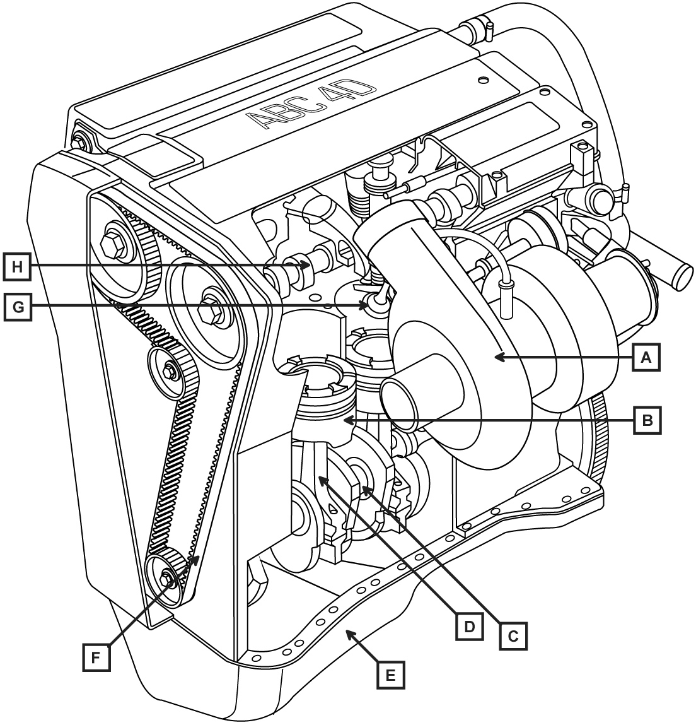
Unit 03 (M/501/7010) | Assessment Criteria 2.1 | Task No 3.3

Task: Compression Ignition Engine Locking Devices

Instructions to learners
To prevent nuts and bolts loosening in service, various forms of locking devices can be used.
Below are examples of locking devices. In the box provided, explain how each device prevents loosening

Locking Device | Name | How it prevents loosening
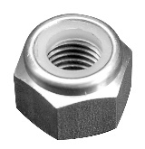 | Nylon Insert  Lock nut
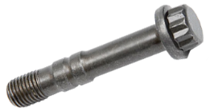 | Stretch Bolt
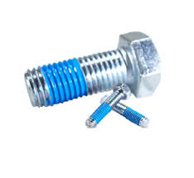 | Threadlock applied to bolt
 | Shakeproof Washer
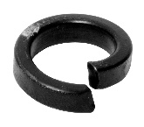 | Spring washer

Assessor Checklist | Achieved  Y/N
Locking Devices identified
Use correctly identified

Assessor Declaration
In signing this sheet the assessor and learner confirm that all the operations in this task were carried out by the named learner and the learner observed safe working practices at all times.

Assessor Signature……………………………………………………............ Date………………………..

Learner Signature.………………………………………………………..……….. Date………………………..

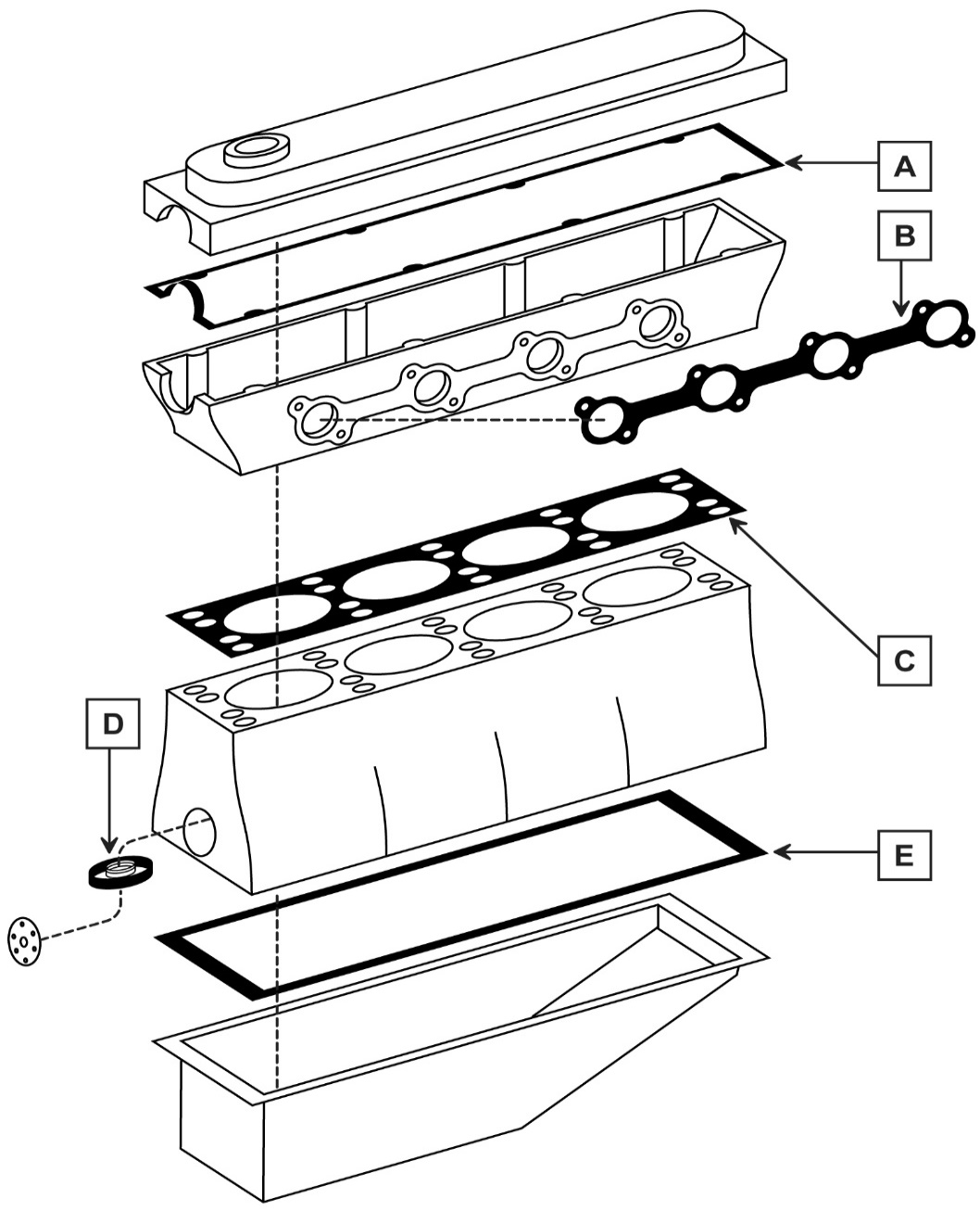

Unit 03 (M/501/7010) | Assessment Criteria 2.1 | Task No 3.4
Task: Compression Ignition Engine Gaskets and Seals

Gasket | Letter | Substance Sealed
 |  | Gas | Water | Oil
Cylinder Head
Cambox Cover
Inlet/Exhaust Manifold
Crankshaft Lip Seal
Sump

Assessor Checklist | Achieved  Y/N
Gaskets and seals identified
Use correctly identified

Assessor Declaration
In signing this sheet the assessor and learner confirm that all the operations in this task were carried out by the named learner and the learner observed safe working practices at all times.

Assessor Signature…………………………………... Date………………….

Learner Signature ……………………………………. Date………………….

UNIT 04 (T/501/7011)
INTRODUCTION TO SPARK IGNITION POWER UNITS

ASSESSMENT CRITERIA RECORD

Specification Reference | Assessment  Criteria | Evidence  Reference*
1.1 | Use safe working practices when working on spark ignition power units | 4.1
2.1 | Identify the major components of the spark ignition engine | 4.2
2.2 | Using methodical procedures, dismantle and reassemble the main components of a four stroke spark ignition engine | 4.1
3.1 | Identify the most common sealing devices used on spark ignition engines to seal:  - Oil  - Water  - Gas  - Fuel | 4.4
3.2 | Identify from samples the main types of locking devices used on spark ignition engines | 4.3
4.1 | Give examples of specialist engine tools used with spark ignition engines | 4.1
4.2 | Select and use specialist workshop tools for appropriate purpose, to include:  - Torque wrench  - Piston ring clamp | 4.1

* Where evidence is provided through responses to underpinning knowledge tests, a copy of the responses must be included as part of the evidence. An evidence reference should be added to the column.

ASSESSOR FEEDBACK ON UNIT COMPLETION
This confirms unit completion and should offer supportive guidance to the learner

Unit 04 (T/501/7011) | Assessment Criteria 1.1 & 2.2 | Task No 4.1

Task: Dismantle Four Stroke Spark Ignition Engine

Vehicle Details | Special Tools | Data
Make___________________  Model___________________  Year____________________ |  | Main Bearing Bolts Torque
 |  | Big End Bolts Torque
 |  | Cylinder Head Bolts Torque

Instructions to learners
- Ensure that the engine is mounted securely
- Remove cylinder head
- Remove sump
- Remove one piston and connecting rod assembly
- Reassemble in reverse order using specialist workshop tools correctly

Assessor Checklist | Achieved  Y/N
PPE selected and used correctly
Methodical Procedures used
Special tools list completed
Data Correct

Assessor Declaration
In signing this sheet the assessor and learner confirm that all the operations in this task were carried out by the named learner and the learner observed safe working practices at all times.

Assessor Signature……………………………………………………............ Date………………………..

Learner Signature.………………………………………………………..……….. Date………………………..

Unit 04 (T/501/7011) | Assessment Criteria 2.1 | Task No 4.2

Task: Spark Ignition Engine Component Recognition

Instructions to learners
Using the experience of dismantling the engine, identify the components indicated on the diagram on the next page.

Assessor Checklist | Achieved  Y/N
Components correctly identified

Assessor Declaration
In signing this sheet the assessor and learner confirm that all the operations in this task were carried out by the named learner and the learner observed safe working practices at all times.

Assessor Signature……………………………………………………............ Date………………………..

Learner Signature.………………………………………………………..……….. Date………………………..

Component | Letter
Piston
Valve
Connecting rod
Timing Belt
Crankshaft
Camshaft
Sump
Exhaust Manifold

Unit 04 (T/501/7011) | Assessment Criteria 2.1 | Task No 4.3

Task: Spark Ignition Engine Locking Devices

Instructions to learners
To prevent nuts and bolts loosening in service, various forms of locking devices can be used.
Below are examples of locking devices. In the box provided, explain how each device prevents loosening

Locking Device | Name | How it prevents loosening
Nylon Insert
Lock nut
 | Stretch Bolt
 | Threadlock applied to bolt
 | Shakeproof Washer
 | Spring washer

Assessor Checklist | Achieved  Y/N
Locking Devices identified
Use correctly identified

Assessor Declaration
In signing this sheet the assessor and learner confirm that all the operations in this task were carried out by the named learner and the learner observed safe working practices at all times.

Assessor Signature……………………………………………………............ Date………………………..

Learner Signature.………………………………………………………..……….. Date………………………..

Complete the table below to indicate the letter of the gasket named, the material used in manufacture and the substance sealed
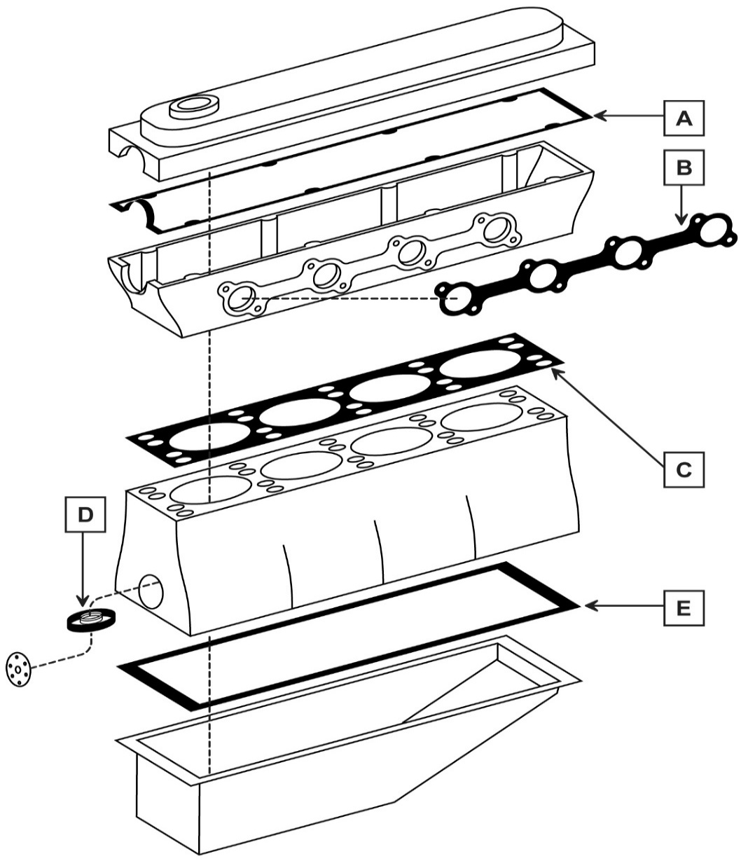
Unit 04 (T/501/7011) | Assessment Criteria 2.1 | Task No 4.4
Task: Spark Ignition Engine Gaskets and Seals

Gasket | Letter | Substance Sealed
 |  | Gas | Water | Oil
Cylinder Head
Cambox Cover
Inlet/Exhaust Manifold
Crankshaft Lip Seal
Sump

Assessor Checklist | Achieved  Y/N
Gaskets and seals identified
Use correctly identified

Assessor Declaration
In signing this sheet the assessor and learner confirm that all the operations in this task were carried out by the named learner and the learner observed safe working practices at all times.

Assessor Signature…………………………………... Date………………….

Learner Signature ……………………………………. Date………………….

UNIT 5 (A/501/7012)
INTRODUCTION TO ENGINE LIQUID COOLING AND ENGINE LUBRICATION SYSTEMS

ASSESSMENT CRITERIA RECORD

Specification Reference | Assessment  Criteria | Evidence  Reference*
1.1 | Use safe working practices when working on engine cooling and lubrication systems | 5.2  5.3  5.5
2.1 | Identify the major components of the engine cooling system | 5.1
2.2 | Using methodical procedures:  - Drain and flush a vehicle liquid cooling system  - Remove and replace a thermostat  - Bleed a vehicle cooling system | 5.2
3.1 | Demonstrate how to mix and install antifreeze solution for a given percentage and system capacity | 5.3
3.2 | Test percentage of antifreeze solution | 5.3
4.1 | Demonstrate how to use a cooling system pressure tester, to test a vehicle’s system for leaks | 5.2  5.3
5.1 | Identify the major components of the engine lubrication system | 5.4
5.2 | Using methodical procedures:  a) Change engine oil and filter  b) Check oil and top up oil level  c) Check for leakage  d) Check operation of engine oil warning light(s) | 5.5

* Where evidence is provided through responses to underpinning knowledge tests, a copy of the responses must be included as part of the evidence. An evidence reference should be added to the column.

ASSESSOR FEEDBACK ON UNIT COMPLETION
This confirms unit completion and should offer supportive guidance to the learner

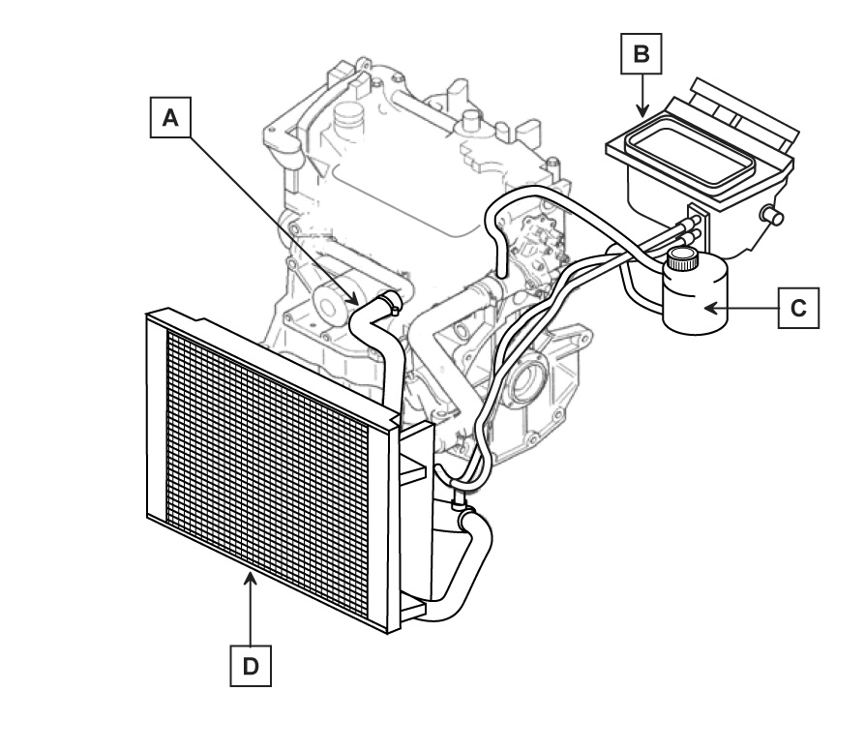
- By inspecting the CROSSFLOW cooling system of a vehicle, identify the components labeled on the diagram.

- Indicate, by arrows, the direction the water flows through the radiator

Component | Letter
Radiator
Hose
Interior Heater
Expansion Tank

Assessor Checklist | Achieved  Y/N
Gaskets and seals identified
Use correctly identified

Assessor Declaration
In signing this sheet the assessor and learner confirm that all the operations in this task were carried out by the named learner and the learner observed safe working practices at all times.

Assessor Signature…………………………………... Date………………….

Learner Signature ……………………………………. Date………………….

Unit 05 (A/501/7012) | Assessment Criteria 2.1 | Task No 5.1
Task: Identification of Engine Crossflow Cooling System Components

Unit 05 (A/501/7012) | Assessment Criteria 2.2 & 4.1 | Task No 5.2

Task:
- Drain and flush a vehicle liquid cooling system
- Remove and replace a thermostat
- Bleed a vehicle cooling system

Vehicle Details | Special Tools | Data
Make___________________  Model___________________  Year____________________ |  | Cooling System Capacity
 |  | Thermostat Stamped Opening Temperature
 |  | Thermostat Actual Opening Temperature
 |  | Cooling System Cap Pressure
Instructions to Learners
- Pressure test cooling system and check for leaks
- Drain Cooling System
- Check Radiator for damage and flush cooling system
- Identify location of cooling system thermostat
- Remove thermostat housing and thermostat
- Test thermostat for correct operation and report findings(Optional)
- Clean housing surfaces and make or fit new gasket
- Refit thermostat and housing
- Tighten housing bolts to correct torque
- Refill system and bleed as required
- Pressure test cooling system and check for leaks

Assessor Checklist | Achieved  Y/N
PPE selected and correctly used
Methodical procedures used
Special tools list completed
Data correct

Assessor Declaration
In signing this sheet the assessor and learner confirm that all the operations in this task were carried out by the named learner and the learner observed safe working practices at all times.

Assessor Signature……………………………………………………............ Date………………………..

Learner Signature.………………………………………………………..……….. Date………………………..

Unit 05 (A/501/7012) | Assessment Criteria 3.1, 3.2 & 4.1 | Task No 5.3

Task:
- Test Cooling System Antifreeze Strength
- Mix and install Antifreeze

Vehicle Details | Special Tools | Data
Make___________________  Model___________________  Year____________________ |  | Cooling System Capacity
 |  | Cooling System Cap Pressure
 |  | Antifreeze % Required
 |  | Antifreeze Quantity
Instructions to Learners
- Pressure test cooling system and check for leaks
- Test antifreeze proportion in cooling system
- Drain Cooling System
- Mix antifreeze to recommended proportion
- Refill system and bleed as required
- Pressure test cooling system and check for leaks

Assessor Checklist | Achieved  Y/N
PPE selected and correctly used
Methodical procedures used
Special tools list completed
Data correct

Assessor Declaration
In signing this sheet the assessor and learner confirm that all the operations in this task were carried out by the named learner and the learner observed safe working practices at all times.

Assessor Signature……………………………………………………............ Date………………………..

Learner Signature.………………………………………………………..……….. Date………………………..

Unit 05 (A/501/7012) | Assessment Criteria 5.1 | Task No 5.4

Task: Identification of Engine Lubrication System Components

By examining an engine lubrication system, identify the components listed on the diagram in the table below
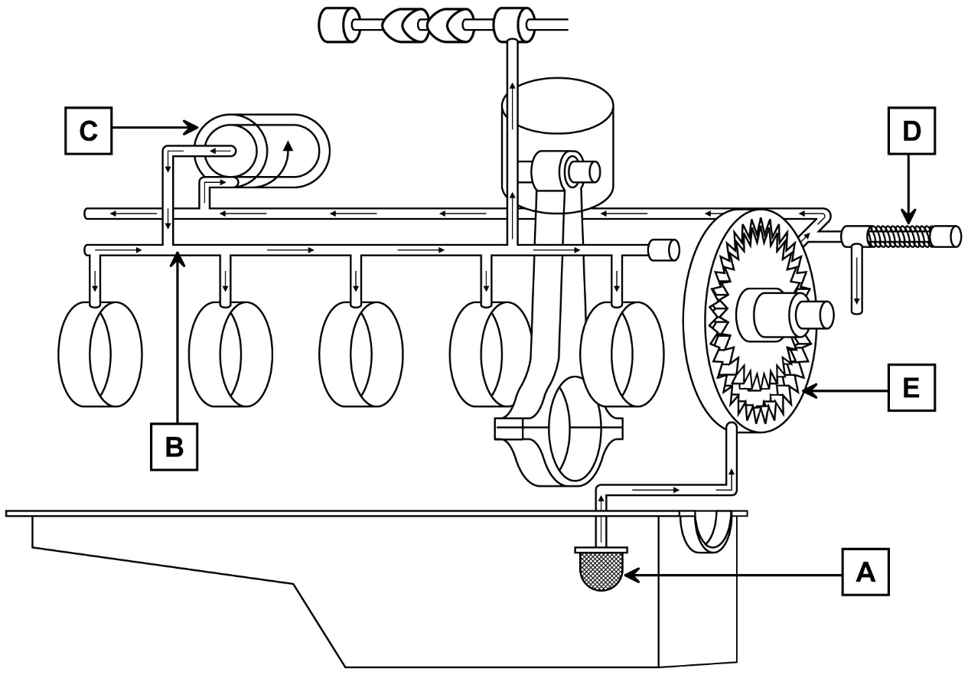

Component | Letter
Oil Pick Up
Oil Pump
Main Oil Gallery
Oil Filter
Oil Pressure Relief Valve

Assessor Checklist | Achieved  Y/N
Components correctly identified

Assessor Declaration
In signing this sheet the assessor and learner confirm that all the operations in this task were carried out by the named learner and the learner observed safe working practices at all times.

Assessor Signature……………………………………………………............ Date………………………..

Learner Signature.………………………………………………………..……….. Date………………………..

Unit 05 (A/501/7012) | Assessment Criteria 5.2 | Task No 5.5

Task:
- Change engine oil and filter
- Check oil and top up oil level
- Check for leakage
- Check operation of engine oil warning light(s)

Vehicle Details | Special Tools | Data
Make___________________  Model___________________  Year____________________ |  | Engine oil Specification
 |  | Sump capacity including filter
Instructions to Learners
- Run engine to warm engine oil
- Position vehicle at correct working height
- Drain engine oil into suitable container (Beware of the dangers of hot engine oil)
- Remove oil filter
- Refit sump plug with new gasket
- Fit new oil filter and seal
- Return vehicle to ground level
- Replenish engine oil
- Run engine and check oil pressure warning lamp operation
- Stop engine and check for oil leaks
- Check oil level. Correct as required
- Dispose of waste correctly

Assessor Checklist | Achieved  Y/N
PPE selected and correctly used
Methodical procedures used
Special tools list completed
Data correct

Assessor Declaration
In signing this sheet the assessor and learner confirm that all the operations in this task were carried out by the named learner and the learner observed safe working practices at all times.

Assessor Signature……………………………………………………............ Date………………………..

Learner Signature.………………………………………………………..……….. Date………………………..

UNIT 6 (F/501/7013)
INTRODUCTION TO SPARK IGNITION AND COMPRESSION IGNITION FUEL SYSTEMS

ASSESSMENT CRITERIA RECORD

Specification Reference | Assessment  Criteria | Evidence  Reference*
1.1 | Use safe working practices when working on engine fuel systems | All Jobcards
2.1 | Identify the major parts of the fuel system of both the spark ignition and compression ignition engines, to include:  - Fuel tank  - Fuel line  - Fuel filter  - Fuel pressurizing system  - Fuel metering system  - Fuel delivery system  - Air intake and filtration | SI 6.1  CI 6.2
3.1  3.2  3.3  3.4 | Change an engine air filter element.  Change a spark ignition engine fuel filter  Change a compression ignition engine fuel filter and bleed system.  Perform visual check for fuel leakage | SI 6.3  CI 6.4  6.3  6.4  6.3 6.4
4.1 | Demonstrate appropriate ways to dispose of waste products in accordance with environmental guidance. | SI 6.3  CI 6.4

* Where evidence is provided through responses to underpinning knowledge tests, a copy of the responses must be included as part of the evidence. An evidence reference should be added to the column.

ASSESSOR FEEDBACK ON UNIT COMPLETION
This confirms unit completion and should offer supportive guidance to the learner

Unit 06 (F/501/7013) | Assessment Criteria 2.1 | Task No 6.1

Task: Identify Fuel System Components (SI Engine)

Learner Instructions

By investigating the fuel system of a vehicle having PETROL FUEL INJECTION system, identify the location of the components listed in the table below
Component | Location
Fuel tank
Fuel Pump
Fuel Filter
Electronic Control Unit (ECU)
Fuel Injector
Air Filter

Assessor Checklist | Achieved  Y/N
Components Identified correctly

Assessor Declaration
In signing this sheet the assessor and learner confirm that all the operations in this task were carried out by the named learner and the learner observed safe working practices at all times.

Assessor Signature……………………………………………………............ Date………………………..

Learner Signature.………………………………………………………..……….. Date………………………..

Unit 06 (F/501/7013) | Assessment Criteria 2.1 | Task No 6.1

Task: Identify Fuel System Components (SI Engine)

Learner Instructions

By investigating the fuel system of a vehicle having DIESEL FUEL INJECTION system, identify the location of the components listed in the table below
Component | Location
Fuel tank
Fuel Pump
Fuel Filter
Electronic Control Unit (ECU)
Fuel Injector
Air Filter

Assessor Checklist | Achieved  Y/N
Components Identified correctly

Assessor Declaration
In signing this sheet the assessor and learner confirm that all the operations in this task were carried out by the named learner and the learner observed safe working practices at all times.

Assessor Signature……………………………………………………............ Date………………………..

Learner Signature.………………………………………………………..……….. Date………………………..

Unit 06 (F/501/7013) | Assessment Criteria 2.1 | Task No 6.2

Task: Identify Fuel System Components (CI Engine)

Learner Instructions

By investigating the fuel system of a vehicle having DIESEL FUEL INJECTION system, identify the location of the components listed in the table below
Component | Location
Fuel tank
Fuel Pump
Fuel Filter
Electronic Control Unit (ECU)
Fuel Injector
Air Filter

Assessor Checklist | Achieved  Y/N
Components Identified correctly

Assessor Declaration
In signing this sheet the assessor and learner confirm that all the operations in this task were carried out by the named learner and the learner observed safe working practices at all times.

Assessor Signature……………………………………………………............ Date………………………..

Learner Signature.………………………………………………………..……….. Date………………………..

Unit 06 (F/501/7013) | Assessment Criteria 3.1, 3.2 & 3.4 | Task No 6.3

Task: Replace Air and Fuel Filters (SI Engine)

Vehicle Details | Special Tools | Data
Make___________________  Model___________________  Year____________________ |  | Component | Disposal Method
 |  | Air Filter
 |  | Fuel Filter
 |  | Split Fuel
 |  | Soiled Rags
Instructions to Learners
- Locate the positions of the air and fuel filter
- Remove air filter and inspect
- Clean air filter housing
- Replace air filter
- Remove fuel filter following manufacturers recommendations
- Replace fuel filter and bleed system as required
- Start engine and check for correct operation and fuel leaks
- Complete the table above outlining correct waste disposal methods

Assessor Checklist | Achieved  Y/N
PPE selected and correctly used
Methodical procedures used
Special tools list completed
Waste Disposal correct

Assessor Declaration
In signing this sheet the assessor and learner confirm that all the operations in this task were carried out by the named learner and the learner observed safe working practices at all times.

Assessor Signature……………………………………………………............ Date………………………..

Learner Signature.………………………………………………………..……….. Date………………………..

Unit 06 (F/501/7013) | Assessment Criteria 3.1, 3.3 & 3.4 | Task No 6.4

Task: Replace Air and Fuel Filters (CI Engine)

Vehicle Details | Special Tools | Data
Make___________________  Model___________________  Year____________________ |  | Component | Disposal Method
 |  | Air Filter
 |  | Fuel Filter
 |  | Split Fuel
 |  | Soiled Rags
Instructions to Learners
- Locate the positions of the air and fuel filter
- Remove air filter and inspect
- Clean air filter housing
- Replace air filter
- Remove fuel filter following manufacturers recommendations
- Replace fuel filter and bleed system as required
- Start engine and check for correct operation and fuel leaks
- Complete the table above outlining correct waste disposal methods

Assessor Checklist | Achieved  Y/N
PPE selected and correctly used
Methodical procedures used
Special tools list completed
Waste Disposal correct

Assessor Declaration
In signing this sheet the assessor and learner confirm that all the operations in this task were carried out by the named learner and the learner observed safe working practices at all times.

Assessor Signature……………………………………………………............ Date………………………..

Learner Signature.………………………………………………………..……….. Date………………………..

UNIT 7 (J/501/7014)
INTRODUCTION TO VEHICLE TRANSMISSION SYSTEMS

ASSESSMENT CRITERIA RECORD

Specification Reference | Assessment  Criteria | Evidence  Reference*
1.1 | Use safe working practices when working on vehicle transmission systems | All Jobcards
2.1 | Identify vehicle transmission layouts as:  - Front engine front wheel drive  - Front engine rear wheel drive  - Mid engine rear wheel drive  - Front engine four wheel drive | 7.1
3.1 | Identify the location of the clutch, gearbox and final drive on a vehicle. | 7.2
4.1 | Identify the location of the torque converter, gear box and final drive on a vehicle | 7.2
5.1  5.2 | Identify, from samples, the main components of a manual clutch assembly as:  - clutch plate  - cover assembly  - thrust bearing  Correctly assemble and align a manual clutch assembly onto an engine flywheel | 7.3
6.1  6.2 | Identify from appropriate data the lubricants used in manual transmission systems  Identify from appropriate data the lubricant used in automatic transmission systems | 7.4
6.3 | Perform a check and top up lubricant level/s in a manual transmission system | 7.4
7.1 | Demonstrate appropriate ways to dispose of waste products in accordance with environmental guidance. | 7.4

* Where evidence is provided through responses to underpinning knowledge tests, a copy of the responses must be included as part of the evidence. An evidence reference should be added to the column.

ASSESSOR FEEDBACK ON UNIT COMPLETION
This confirms unit completion and should offer supportive guidance to the learner

Unit 07 (J/501/7014) | Assessment Criteria 2.1 | Task No 7.1

Task: Identify Vehicle Transmission Layouts

Instructions to Learners
- By investigating the transmission layout of various vehicles, identify on the diagrams below the type of layout shown from the following list.

Front Engine Front Wheel Drive Front Engine Rear Wheel Drive

Mid Engine Rear Wheel Drive Front Engine Four Wheel Drive

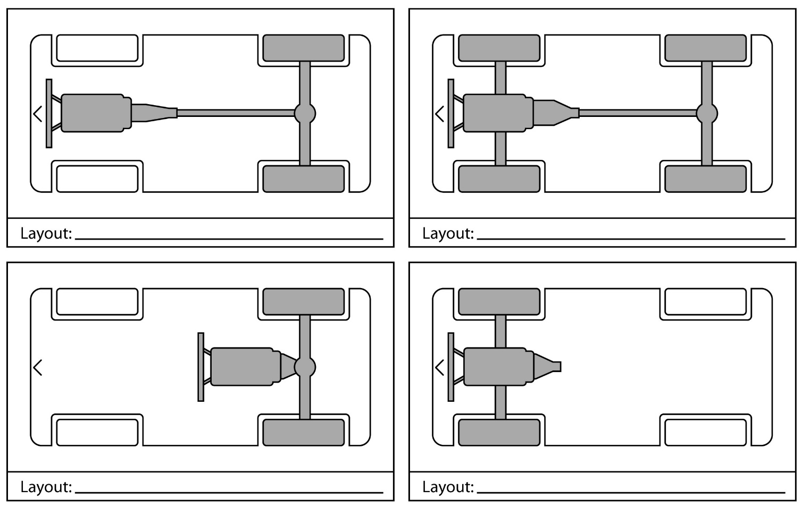

Assessor Checklist | Achieved  Y/N
Layouts Identified Correctly

Assessor Declaration
In signing this sheet the assessor and learner confirm that all the operations in this task were carried out by the named learner and the learner observed safe working practices at all times.

Assessor Signature……………………………………………………............ Date………………………..

Learner Signature.………………………………………………………..……….. Date………………………..

Unit 07 (J/501/7014) | Assessment Criteria 3.1, 4.1 | Task No 7.2

Task: Identify Manual and Automatic Transmission Components

Instructions to Learners
By investigating vehicles with manual and automatic transmission systems and with reference to the lettered components on the diagram on the next page, identify the components listed in the table below the diagram.
State in the table provided whether the component is part of a manual or automatic transmission system. Some have been completed to help you.

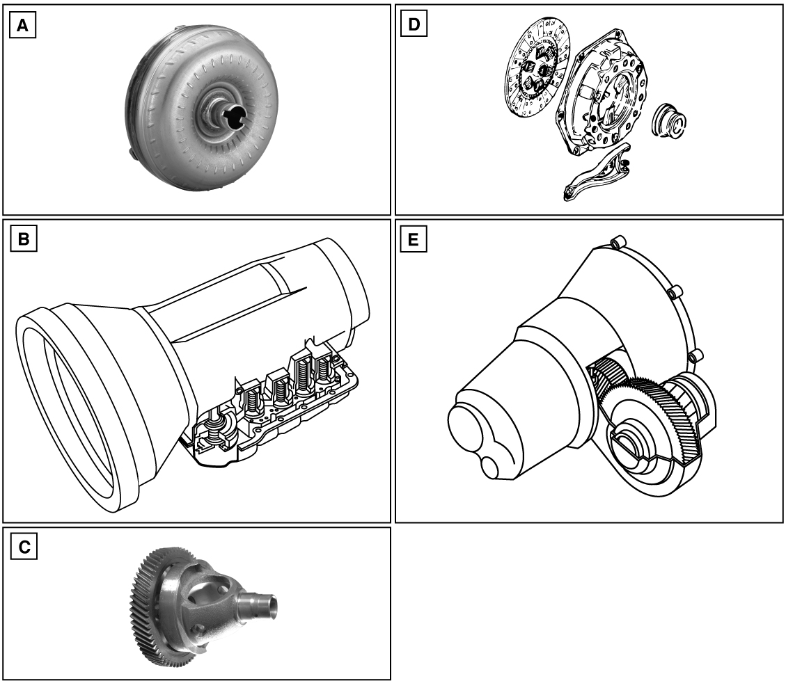
Component | Letter | Manual/ Automatic
Clutch
Gearbox |  | Automatic
Gearbox |  | Manual
Torque Converter
Final drive |  | Automatic & Manual

Assessor Checklist | Achieved  Y/N
Layouts Identified Correctly

Assessor Declaration
In signing this sheet the assessor and learner confirm that all the operations in this task were carried out by the named learner and the learner observed safe working practices at all times.

Assessor Signature……………………………………………………............ Date………………………..

Learner Signature.………………………………………………………..……….. Date………………………..

Unit 07 (J/501/7014) | Assessment Criteria 5.1, 5.2 | Task No 7.3

Task: Replace Manual Transmission Clutch Assembly

Vehicle Details | Special Tools | Data
Make___________________  Model___________________  Year____________________ |  | Component | Condition
 |  | Clutch Plate
 |  | Cover Assembly
 |  | Thrust Bearing
Instructions to Assessor
For this Task: the engine and transmission system should be removed from the vehicle and secured to allow safe removal and refitting of the clutch assembly

Instructions to learners
- Remove the gearbox from the engine
- Remove the clutch assembly and check for condition
- refit the clutch assembly, using appropriate aligning tools
- Refit the gearbox
- Complete the condition report
- Identify in the diagram below, the names of the clutch components
E
D
C
B
A
Component | Letter
Clutch Fork
Clutch Plate
Flywheel
Thrust bearing
Cover Assembly
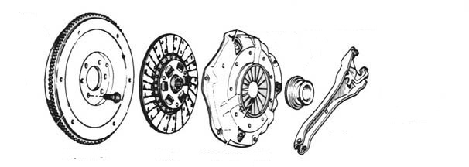

Assessor Checklist | Achieved  Y/N
PPE selected and correctly used
Methodical procedures used
Special tools list completed
Report and identification accurate

Assessor Declaration
In signing this sheet the assessor and learner confirm that all the operations in this task were carried out by the named learner and the learner observed safe working practices at all times.

Assessor Signature……………………………………………………............ Date………………………..

Learner Signature.………………………………………………………..……….. Date………………………..

Unit 07 (J/501/7014) | Assessment Criteria 6.1, 6.2, 6.3, 7.1 | Task No 7.4

Task: Top-Up Transmission Lubricant levels

Vehicle Details | Special Tools | Data
Make___________________  Model___________________  Year____________________  Transmission Type:  (Automatic/Manual)  _______________________ |  | Gearbox Oil Capacity
 |  | Final drive oil Capacity
 |  | Manual Gearbox Oil Specification
 |  | Automatic Gearbox Oil Specification
Instructions to Assessor
- Position vehicle at correct working height
- Locate the gearbox level plug or dipstick
- Following manufacturers recommendations, check the fluid level and top-up as required
- Locate the final drive level plug
- Following manufacturers recommendations, check the fluid level and top-up as required
- Complete the data list
- State below how the waste oil should be disposed of

___________________________________________________________________
___________________________________________________________________
___________________________________________________________________

Assessor Checklist | Achieved  Y/N
PPE selected and correctly used
Methodical procedures used
Special tools list completed
Waste Disposal correct

Assessor Declaration
In signing this sheet the assessor and learner confirm that all the operations in this task were carried out by the named learner and the learner observed safe working practices at all times.

Assessor Signature……………………………………………………............ Date………………………..

Learner Signature.………………………………………………………..……….. Date………………………..

UNIT 8 (L/501/7015)
INTRODUCTION TO BATTERY AND LIGHTING SYSTEMS

ASSESSMENT CRITERIA RECORD

Specification Reference | Assessment  Criteria | Evidence  Reference*
1. Work safely | 1.1 Use safe working practices when working on vehicle battery and lighting systems | All Job cards
2. Know about vehicle batteries | 2.1 Identify the correct battery for a specified vehicle, e.g. diesel, petrol.  2.2 Using methodical procedures  - Locate a vehicle battery  - Remove a vehicle battery  - Refit a vehicle battery observing polarity connections  2.3 Test vehicle battery voltage at  - Engine off no load  - Engine cranking  - Engine running at 3000 revs  2.4 Identify key findings from vehicle battery voltage tests | 8.1  8.1  8.1  8.1
3. Know about external vehicle lighting systems | 3.1 Locate the components of a vehicle external lighting system to include:  - Side lights  - Head lamps  - Direction indicators  - Hazard warning lights  - Stop lights  - Reverse lights  - Fog lights  - Number plate lamps  3.2 Perform an vehicle external lighting check  - Identify key findings from vehicle lighting check  3.4 Replace the bulbs/lamps for at least one of the following:  - side lamps  - rear lamps  - direction indicator lamps | 8.2  8.2  8.3
4. Know about internal vehicle lighting systems | 4.1 Locate the components of a vehicle internal lighting system to include:  - Courtesy lights  - Dashboard illumination lights  - Driver information lights | 8.4
5. Know about driver information warning lights | 5.1 Locate and check the operation of at least six driver information warning lights to include:  - Oil pressure warning light  - No charge warning light  - Brake warning light | 8.4
6. Know about vehicle circuit protection | 6.1 Identify lighting circuit fuse location and value  6.2 Locate, remove, test and replace a lighting circuit fuse | 8.5
7. Be aware of environmental considerations | 7.1 Demonstrate appropriate ways to dispose of waste products in accordance with environmental guidance

* Where evidence is provided through responses to underpinning knowledge tests, a copy of the responses must be included as part of the evidence. An evidence reference should be added to the column.

ASSESSOR FEEDBACK ON UNIT COMPLETION
This confirms unit completion and should offer supportive guidance to the learner

Unit 08 (L/501/7015) | Assessment Criteria 2.1, 2.2, 2.3 & 2.4 | Task No 8.1

Task: Remove, Refit and Test a Vehicle Battery

Vehicle Details | Special Tools | Data
Make___________________  Model___________________  Year____________________ |  | Off Load
 |  | Engine Cranking
 |  | Charging Voltage
Instructions to Learners

WARNING
When a vehicle battery is removed it may have an effect on the vehicle operation.
Before removing a vehicle battery ensure;
- The ignition keys are removed from the vehicle
- The car radio code is known
- The engine management system will not be affected by battery removal

Identify the vehicle battery and note the specification
in the table opposite.
Battery Specification
Specification | Actual | Recommended
Voltage

Ampere-Hour Rating

Cold Cranking Amperage
The battery is suitable YES/NO_________
- Compare to recommended specification to confirm suitability
- Remove the battery carrier
- Remove the vehicle battery following a safe methodical approach
- Clean the battery terminals and refit
the battery and carrier
- Connect a voltmeter to the battery
and check the voltage;
  - Off load
  - Engine Cranking
  - Engine Running and alternator charging
- Complete the voltage report

Assessor Checklist | Achieved  Y/N
PPE selected and correctly used
Methodical procedures used
Special tools list completed
Reports completed using correct data

Assessor Declaration
In signing this sheet the assessor and learner confirm that all the operations in this task were carried out by the named learner and the learner observed safe working practices at all times.

Assessor Signature……………………………………………………............ Date………………………..

Learner Signature.………………………………………………………..……….. Date………………………..

Unit 08 (L/501/7015) | Assessment Criteria 3.1, 3.2 & 3.3 | Task No 8.2

Task: External Lighting Check

Vehicle Details | Waste Disposal
Make_______________  Model_______________  Year________________ | Lights | Report
 | Front sidelights
 | Front headlamps(dip)
 | Front headlamps(main beam)
 | Front direction indicators
 | Side direction indicators
 | Rear lights
 | Stop lights including high level
 | Rear Direction Indicator lights
 | Reverse lights
 | Rear fog light
 | Number plate illumination light
 | Hazard warning lights
Instructions to Learners
Inspect the condition and operation of vehicle exterior lights and complete the report above.

Assessor Checklist | Achieved  Y/N
PPE selected and correctly used
Methodical procedures used
Report completed

Assessor Declaration
In signing this sheet the assessor and learner confirm that all the operations in this task were carried out by the named learner and the learner observed safe working practices at all times.

Assessor Signature……………………………………………………............ Date………………………..

Learner Signature.………………………………………………………..……….. Date………………………..

Unit 08 (L/501/7015) | Assessment Criteria 3.1, 3.2 & 3.3 | Task No 8.2

Task: External Lighting Check

Vehicle Details | Special Tools | Data
Make_______________  Model_______________  Year________________ |  | Bulb Selected
 |  | Specification
 |  | Voltage
 |  | Wattage
Instructions to Learners
- Locate faulty lamp from
a) side lamps or
b) rear lamps or
c) direction indicator lamps
- Remove faulty bulb following manufacturers instructions
- Test bulb for failure using a ohmmeter
- Check replacement bulb for voltage and wattage
- Fit replacement bulb and secure bulb holder
- Complete data sheet

Assessor Checklist | Achieved  Y/N
PPE selected and correctly used
Methodical procedures used
Report completed

Assessor Declaration
In signing this sheet the assessor and learner confirm that all the operations in this task were carried out by the named learner and the learner observed safe working practices at all times.

Assessor Signature……………………………………………………............ Date………………………..

Learner Signature.………………………………………………………..……….. Date………………………..

Unit 08 (L/501/7015) | Assessment Criteria 4.1 & 5.1 | Task No 8.4

Task: Check Interior Lights
Check Driver Information Lights

Vehicle Details | Interior Lighting Test Report
Make_______________  Model_______________  Year________________ | Interior Courtesy Light |  |  | OK Y/N
 | Manual
 | Door
 | Dashboard Illumination |  |  | OK Y/N
 | Dimmer
Instructions to Learners
- Locate interior courtesy light and check operation by
  - manual operation
  - opening of each door.
- Switch on vehicle sidelights and check operation of dashboard illumination
- Check operation of dashboard illumination dimmer.
- Complete interior lighting test report
- Identify the driver information lights in the list below.
- Complete the report by stating when the lights are lit and sketch the symbol used

Warning Lamp |  | When Lit | Symbol
Headlamp Main Beam
Oil Pressure Warning
Battery No Charge
Brake Warning
Engine Management Warning
Rear Fog Light Warning

Assessor Checklist | Achieved  Y/N
PPE selected and correctly used
Methodical procedures used
Report completed

Assessor Declaration
In signing this sheet the assessor and learner confirm that all the operations in this task were carried out by the named learner and the learner observed safe working practices at all times.

Assessor Signature……………………………………………………............ Date………………………..

Learner Signature.………………………………………………………..……….. Date………………………..

Unit 08 (L/501/7015) | Assessment Criteria 6.1 & 6.2 | Task No 8.5

Task: Replace Faulty Fuse

Vehicle Details | Special Tools | Data
Make_______________  Model_______________  Year________________ |  | Fuse Type
 |  | Fuse Rating
 |  | Circuit Protected
Instructions to Learners
- Locate fuse box and the fuse to be changed
- Identify the circuit protected by this fuse
- Remove fuse and check condition using a multimeter.
- Fit replacement fuse

Assessor Checklist | Achieved  Y/N
PPE selected and correctly used
Methodical procedures used
Data completed

Assessor Declaration
In signing this sheet the assessor and learner confirm that all the operations in this task were carried out by the named learner and the learner observed safe working practices at all times.

Assessor Signature……………………………………………………............ Date………………………..

Learner Signature.………………………………………………………..……….. Date………………………..

Unit 08 (L/501/7015) | Assessment Criteria 6.1 & 6.2 | Task No 8.6

Task: Waste Disposal

Learner Instructions
- State in the spaces provided below the correct procedure IN YOUR WORKSHOP for disposing of waste electrical components.

Component | Correct Disposal
Vehicle Battery
Electrical Wiring
Faulty Bulbs
Fuses

Assessor Checklist | Achieved  Y/N
PPE selected and correctly used
Methodical procedures used
Report completed

Assessor Declaration
In signing this sheet the assessor and learner confirm that all the operations in this task were carried out by the named learner and the learner observed safe working practices at all times.

Assessor Signature……………………………………………………............ Date………………………..

Learner Signature.………………………………………………………..……….. Date………………………..

UNIT 9 (R/501/7016)
INTRODUCTION TO STEERING AND SUSPENSION

ASSESSMENT CRITERIA RECORD

Specification Reference | Assessment  Criteria | Evidence  Reference*
1. Work safely | 1.1 Use safe working practices when working on vehicle steering and suspension systems | All Jobcards
2. Know how to remove and replace road wheels | 2.1 Remove and replace road wheels with special attention to:  - safe jacking procedure  - use of correct jacking points  - use of axle stands  - use of torque wrench | 9.1
3. Know about steering systems | 3.1 Identify and locate main components of a non-power-assisted vehicle steering system  3.2 Identify and locate main components of a power assisted vehicle steering system  3.3 Check steering systems for excessive wear and identify key findings  3.4 Remove and replace track rod end  3.5 Check and adjust front wheel alignment  3.6 Check power assisted steering systems for leaks  3.7 Follow correct procedure to check and top-up power assisted steering fluid level | 9.2  9.2  9.3  9.4  9.4  9.5  9.5
4. Know about suspension systems | 4.1 Identify and locate the main components of a vehicle suspension system  4.2 Check suspension system for excessive wear and identify key findings  4.3 Remove and refit front or rear suspension damper | 9.6  9.3  9.7
5. Be aware of environmental considerations | 5.1 Demonstrate appropriate ways to dispose of waste products in accordance with environmental guidance | 9.8

* Where evidence is provided through responses to underpinning knowledge tests, a copy of the responses must be included as part of the evidence. An evidence reference should be added to the column.

ASSESSOR FEEDBACK ON UNIT COMPLETION
This confirms unit completion and should offer supportive guidance to the learner

Unit 09 (R/501/7016) | Assessment Criteria 2.1 | Task No 9.1

Task: Remove and Replace Road Wheel

Vehicle Details | Special Tools | Data
Make_______________  Model_______________  Year________________ |  | Tyre Size
 |  | Wheel Condition
 |  | Tyre Wear
 |  | Tread Depth
 |  | Minimum Legal Tread Depth
 |  | Wheel Nut Torque
Instructions to Learners
- Secure vehicle prior to jacking
- Safely raise the vehicle using a trolley jack and position axle stands
- Remove one road wheel and inspect for
- rim damage
- wheel buckle
- stud hole wear
- Inspect tyre for
- correct size for vehicle
- uneven tyre wear
- tread depth
- correct inflation pressure
- Refit road wheel and lower vehicle safely
- Check Wheel nut torque

Assessor Checklist | Achieved  Y/N
PPE selected and correctly used
Methodical procedures used
Data completed

Assessor Declaration
In signing this sheet the assessor and learner confirm that all the operations in this task were carried out by the named learner and the learner observed safe working practices at all times.

Assessor Signature……………………………………………………............ Date………………………..

Learner Signature.………………………………………………………..……….. Date………………………..

Unit 09 (R/501/7016) | Assessment Criteria 3.1 & 3.2 | Task No 9.2

Task: Identify Steering System Components

Vehicle Details | Component |  | Letter
Make_______________  Model_______________  Year________________ | Steering Wheel
 | Steering Column
 | Steering Rack
 | Track Rod Ends
Instructions to Learners  - Inspect a vehicle steering system and identify the letter of the components in the table above using the diagram opposite.  - Inspect a power assisted steering system and add to the diagram opposite  FLUID POWER STEERING  - the position of the pump, how the pump is driven and piping for a fluid system  OR  ELECTRIC POWER STEERING  - The position of the motor |  | 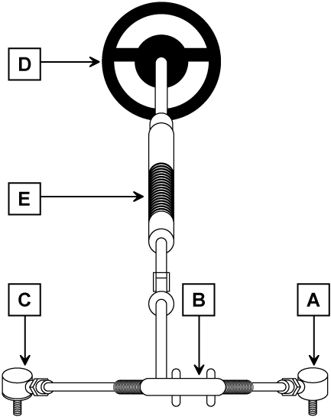

Assessor Checklist | Achieved  Y/N
PPE selected and correctly used
Components identified
Power steering system identified

Assessor Declaration
In signing this sheet the assessor and learner confirm that all the operations in this task were carried out by the named learner and the learner observed safe working practices at all times.

Assessor Signature……………………………………………………............ Date………………………..

Learner Signature.………………………………………………………..……….. Date………………………..

Unit 09 (R/501/7016) | Assessment Criteria 3.3, 4.2 | Task No 9.3

Task: Check Steering and Suspension Systems for Wear and Faults

Vehicle Details | Special Tools
Make___________________________

Model___________________________

Year____________________________

Instructions to Learners
    - Identify the correct methods of checking the steering and suspension system components for wear from manufacturer’s data or by reference to your tutor.
    - Check the systems for wear and with reference to the maximum freeplay, decide if the component or system is in serviceable condition.
NOTE The freeplay data should be taken as a guide only and you should discuss your findings with your tutor before completing the report.

Steering Component | Maximum Freeplay | Report
Steering Wheel | 13mm for rack steering  75mm for steering box
Steering Rack | 5mm
Track Rod Ends | Zero play OR as per manufacturers recommendation
Suspension Component | Specification | Report
Trim Height | Within manufacturer’s limits
Suspension Joints | Zero play OR as per manufacturers recommendation
Shock Absorber Leaks | No leaks
Shock Absorber Bounce Test | 1 rebound and return to original position

Assessor Checklist | Achieved  Y/N
PPE selected and correctly used
Methodical Procedures used
Report completed

Assessor Declaration
In signing this sheet the assessor and learner confirm that all the operations in this task were carried out by the named learner and the learner observed safe working practices at all times.

Assessor Signature……………………………………………………............ Date………………………..

Learner Signature.………………………………………………………..……….. Date………………………..

Unit 09 (R/501/7016) | Assessment Criteria 3.4, 3.5 | Task No 9.4

Task: Remove and Replace Track Rod End
Check and Adjust Wheel Alignment

Vehicle Details | Special Tools | Data
Make_______________  Model_______________  Year________________ |  | Wheel Alignment
 |  | Wheel Nut Torque
Instructions to Learners
- Position vehicle at correct working height.
- Identify the steered wheels and remove one wheel
- Following manufacturer’s instructions, remove one track rod end ensuring the number of rotations to remove it is noted
- Refit the track rod end, ensuring correct location by returning it the same number of rotations.
- Refit the wheel
- Set up the wheel alignment equipment according to the product manufacturer’s instructions.
- Measure the wheel alignment and compare to that recommended.
- Adjust wheel alignment as required.
- Refit wheel and torque wheel nuts
- Check for correct operation

Assessor Checklist | Achieved  Y/N
PPE selected and correctly used
Methodical Procedures used
Data table complete

Assessor Declaration
In signing this sheet the assessor and learner confirm that all the operations in this task were carried out by the named learner and the learner observed safe working practices at all times.

Assessor Signature……………………………………………………............ Date………………………..

Learner Signature.………………………………………………………..……….. Date………………………..

Unit 09 (R/501/7016) | Assessment Criteria 3.6, 3.7 | Task No 9.5

Task: Check Power Assisted Steering System for Leaks
Check and Top-Up Fluid Power Steering System

Vehicle Details | Special Tools | Power Steering Fluid Specification
Make_______________

Model_______________

Year________________
Instructions to Learners
- With the engine at idle speed, turn the steering wheel from lock to lock and listen for power steering operation
- Stop engine and visually check the pump, hoses and connections for leaks
- Following manufacturers guidelines, check the reservoir fluid level and adjust as required

Assessor Checklist | Achieved  Y/N
PPE selected and correctly used
Methodical Procedures used
Data table complete

Assessor Declaration
In signing this sheet the assessor and learner confirm that all the operations in this task were carried out by the named learner and the learner observed safe working practices at all times.

Assessor Signature……………………………………………………............ Date………………………..

Learner Signature.………………………………………………………..……….. Date………………………..

Unit 09 (R/501/7016) | Assessment Criteria 4.1 | Task No 9.6

Task: Identify Suspension Components

Instructions to Learners
Investigate THREE suspension systems and complete a report for each

Report 1
Suspension Type | Type of Spring | The spring is positioned between the  ____________________  and the  ____________________. | The damper is a  ______________________type and is positioned between the  ___________________and the  ________________________.

Report 2
Suspension Type | Type of Spring | The spring is positioned between the  ____________________  and the  ____________________. | The damper is a  ______________________type and is positioned between the  ___________________and the  ________________________.

Report 3
Suspension Type | Type of Spring | The spring is positioned between the  ____________________  and the  ____________________. | The damper is a  ______________________type and is positioned between the  ___________________and the  ________________________.

Assessor Checklist | Achieved  Y/N
PPE selected and correctly used
Methodical Procedures used
Reports complete

Assessor Declaration
In signing this sheet the assessor and learner confirm that all the operations in this task were carried out by the named learner and the learner observed safe working practices at all times.

Assessor Signature……………………………………………………............ Date………………………..

Learner Signature.………………………………………………………..……….. Date………………………..

Unit 09 (R/501/7016) | Assessment Criteria 4.3 | Task No 9.7

Task: Remove and Replace Suspension Damper

Vehicle Details | Special Tools | Wheel Nut Torque
Make_______________

Model_______________

Year________________
Instructions to Learners
- Identify damper to be replaced
- Raise the vehicle to correct working height
- Jack-up the vehicle and place axle stands under the chassis
- Following manufacturer’s procedures, remove the suspension damper with particular attention to safety procedures.
- Inspect damper for fluid leaks.
- If the suspension spring is part of the damper, then remove the suspension spring observing all safety procedures.
- Manually test the damper for condition
- Reassemble the damper and refit to the vehicle.
- Refit all parts and check suspension system for correct operation

Assessor Checklist | Achieved  Y/N
PPE selected and correctly used
Methodical Procedures used
Data table complete

Assessor Declaration
In signing this sheet the assessor and learner confirm that all the operations in this task were carried out by the named learner and the learner observed safe working practices at all times.

Assessor Signature……………………………………………………............ Date………………………..

Learner Signature.………………………………………………………..……….. Date………………………..

Unit 09 (R/501/7016) | Assessment Criteria 5.1 | Task No 9.8

Task: Waste Disposal

Instructions to Learners
State in the spaces provided below the correct procedure for disposing of waste steering and suspension components IN YOUR WORKSHOP.

Component | Correct Disposal
Power Steering Fluid
Waste Components

Assessor Checklist | Achieved  Y/N
PPE selected and correctly used
Methodical Procedures used
Report completed

Assessor Declaration
In signing this sheet the assessor and learner confirm that all the operations in this task were carried out by the named learner and the learner observed safe working practices at all times.

Assessor Signature……………………………………………………............ Date………………………..

Learner Signature.………………………………………………………..……….. Date………………………..

UNIT 10 (R/501/7016)
INTRODUCTION TO STEERING AND SUSPENSION

ASSESSMENT CRITERIA RECORD

Specification Reference | Assessment  Criteria | Evidence  Reference*
1. Work safely | 1.1 Use safe working practices when working on vehicle braking systems | All Jobcards
2. Know how to remove and replace road wheels | 2.1 Remove and replace road wheels with special attention to:  - safe jacking procedure  - use of correct jacking points  - use of axle stands  - use of torque wrench | 9.1
3. Know about braking systems | 3.1 Identify and locate the main components of a vehicle braking system to include:  - master cylinder  - brake servo  - disc brakes  - drum brakes  - parking brake  - warning lights  3.2 Identify the wheels that the parking brake operates  3.3 Remove and replace disc pads and report on the condition of:  - brake pads  - brake discs  - brake caliper  - flexible brake hose  3.4 Remove and replace brake drum and report on condition of:  - brake drum  - brake shoes  - brake wheel cylinders  3.5 Perform checks on condition of:  - brake fluid  - operation of brake warning lights  3.6 Check and top-up brake fluid reservoir | 10.2  10.2  10.3  10.4  10.5
4. Be aware of environmental considerations | 4.1 Demonstrate appropriate ways to dispose of waste products in accordance with environmental guidance | 10.6

* Where evidence is provided through responses to underpinning knowledge tests, a copy of the responses must be included as part of the evidence. An evidence reference should be added to the column.

ASSESSOR FEEDBACK ON UNIT COMPLETION
This confirms unit completion and should offer supportive guidance to the learner

Unit 10 (Y/501/7017) | Assessment Criteria 2.1 | Task No 10.1

Task: Remove and Replace Road Wheel

Vehicle Details | Special Tools | Data
Make_______________  Model_______________  Year________________ |  | Tyre Size
 |  | Wheel Condition
 |  | Tyre Wear
 |  | Tread Depth
 |  | Minimum Legal Tread Depth
 |  | Wheel Nut Torque
Instructions to Learners
- Secure vehicle prior to jacking
- Safely raise the vehicle using a trolley jack and position axle stands
- Remove one road wheel and inspect for
- rim damage
- wheel buckle
- stud hole wear
- Inspect tyre for
- correct size
- vehicle
- uneven tyre wear
- tread depth
- correct inflation pressure
- Refit road wheel and lower vehicle safely
- Check Wheel nut torque

Assessor Checklist | Achieved  Y/N
PPE selected and correctly used
Methodical Procedures used
Data completed

Assessor Declaration
In signing this sheet the assessor and learner confirm that all the operations in this task were carried out by the named learner and the learner observed safe working practices at all times.

Assessor Signature……………………………………………………............ Date………………………..

Learner Signature.………………………………………………………..……….. Date………………………..

Unit 10 (Y/501/7017) | Assessment Criteria 3.1 & 3.2 | Task No 10.2

Task: Remove and Replace Road Wheel

Instructions to Learners
    - Inspect a vehicle braking system and identify the components numbered in the diagram.
    - Complete the Braking System Components chart below
    - Investigate 4 other vehicle braking systems and complete the systems layout report below.
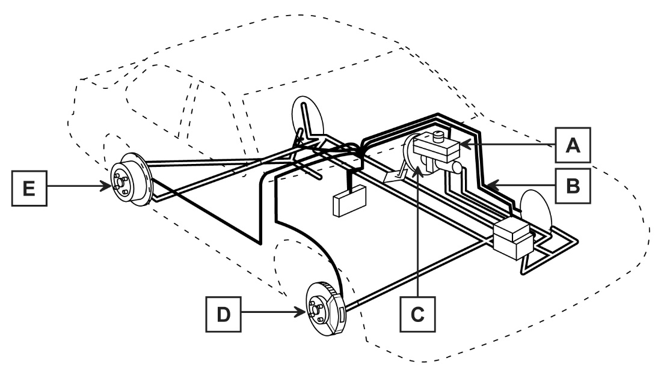
Braking System Components
Component | Number
Disc Brake
Drum Brake
Master Cylinder
Servo
Metal brake pipe

System Layout Report
Make/Model | FrontBrake  (Disc or Drum) | Rear Brake  (Disc or Drum) | Wheels braked by handbrake  (Front or Rear) | Handbrake operated by  Lever(L)  Button(B)  Switch(S)

Assessor Checklist | Achieved  Y/N
PPE selected and correctly used
Methodical Procedures used
Reports completed

Assessor Declaration
In signing this sheet the assessor and learner confirm that all the operations in this task were carried out by the named learner and the learner observed safe working practices at all times.

Assessor Signature……………………………………………………............ Date………………………..

Learner Signature.………………………………………………………..……….. Date………………………..

Unit 10 (Y/501/7017) | Assessment Criteria 3.3 | Task No 10.3

Task: Remove and Replace Disc Pads

Vehicle Details | Special Tools |  | Data
Make_______________  Model_______________  Year________________ |  |  | Min Disc Pad Thickness
 |  |  | Min Disc Thickness
Max Disc
Run-out
 |  |  | Wheel Nut Torque
Instructions to Learners  - Position vehicle at correct working height  - Identify the wheels fitted with disc brakes  - Remove one wheel  - Remove the disc pads following manufacturers procedures  - Check pads for serviceability and report findings  - Measure the disc thickness with a micrometer  and report findings  - Measure the disc run-out with a dial test indicator and report findings.  - Check caliper for correct operation  - Check flexible brake hose(s) for cracks and wear  - Refit pads to manufacturers specification  - Refit wheel  - Press the brake pedal repeatedly to adjust pads  - Press and hold brake pedal and check for correct operation |  | Report
 |  | Component |  | Condition
 |  | Disc Pads
 |  | Caliper
 |  | Disc Thickness
 |  | Disc Run-out
 |  | Brake Hose

Assessor Checklist | Achieved  Y/N
PPE selected and correctly used
Methodical Procedures used
Data and report completed

Assessor Declaration
In signing this sheet the assessor and learner confirm that all the operations in this task were carried out by the named learner and the learner observed safe working practices at all times.

Assessor Signature……………………………………………………............ Date………………………..

Learner Signature.………………………………………………………..……….. Date………………………..

Unit 10 (Y/501/7017) | Assessment Criteria 3.4 | Task No 10.4

Task: Remove and Replace Brake Drum
Report on Component Condition

Vehicle Details | Special Tools | Report
Make_______________  Model_______________  Year________________ |  | Component | Condition
 |  | Brake Shoes
 |  | Wheel Cylinder
 |  | Brake Drum
 |  | Springs and Clips
Instructions to Learners
- Position vehicle at correct working height
- Identify the wheels fitted with drum brakes
- Remove one wheel
- Release the handbrake
- Remove the brake drum following manufacturers instructions
- Note the position of brake shoes, springs, handbrake attachment and adjuster mechanisms
- Check wheel cylinder for operation and fluid leaks and report condition
- Refit the brake drum
- Following manufacturers recommendations, adjust the shoe-to-drum clearance
- Refit the wheel
- Check braking system for correct operation

Assessor Checklist | Achieved  Y/N
PPE selected and correctly used
Methodical Procedures used
Report completed

Assessor Declaration
In signing this sheet the assessor and learner confirm that all the operations in this task were carried out by the named learner and the learner observed safe working practices at all times.

Assessor Signature……………………………………………………............ Date………………………..

Learner Signature.………………………………………………………..……….. Date………………………..

Unit 10 (Y/501/7017) | Assessment Criteria 3.5 & 3.6 | Task No 10.5

Task: Check Brake Fluid Level and Condition
Check Operation of Low Fluid Warning Lamp (where fitted)

Vehicle Details | Special Tools | Data
Make_______________  Model_______________  Year________________ |  | Brake Fluid Specification DOT
 |  | Low Fluid Switch Location
 |  | Fluid Boiling Point
 |  | Minimum Boiling Point
 |  | Fluid Condition
 |  | Sketch of Low Fluid Warning Lamp Symbol
Instructions to Learners
- Locate “Low brake fluid” Warning Lamp switch
- Operate switch and check operation of warning lamp
- Check brake fluid boiling point or visual condition
- Check brake fluid level and top-up as required

Assessor Checklist | Achieved  Y/N
PPE selected and correctly used
Methodical Procedures used
Data completed

Assessor Declaration
In signing this sheet the assessor and learner confirm that all the operations in this task were carried out by the named learner and the learner observed safe working practices at all times.

Assessor Signature……………………………………………………............ Date………………………..

Learner Signature.………………………………………………………..……….. Date………………………..

Unit 10 (Y/501/7017) | Assessment Criteria 4.1 | Task No 10.6

Task: Waste Disposal

Instructions to Learners
State in the spaces provided below the correct procedure for disposing of waste braking system components IN YOUR WORKSHOP

Component | Correct Disposal
Brake Dust
Brake Fluid
Waste Components

Assessor Checklist | Achieved  Y/N
PPE selected and correctly used
Methodical Procedures used
Report completed

Assessor Declaration
In signing this sheet the assessor and learner confirm that all the operations in this task were carried out by the named learner and the learner observed safe working practices at all times.

Assessor Signature……………………………………………………............ Date………………………..

Learner Signature.………………………………………………………..……….. Date………………………..

UNIT 11 (D/501/7018)
INTRODUCTION TO VEHICLE INSPECTION

ASSESSMENT CRITERIA RECORD

Specification Reference | Assessment  Criteria | Evidence  Reference*
1. Work safely | 1.1 Use safe working practices when undertaking routine vehicle inspection | All Jobcards
2. Know about periodic vehicle inspections | 2.1 Identify key periodic inspections that should be performed on a vehicle and the main reasons for carrying them out.  2.2 Perform straightforward periodic maintenance to include checking and reporting on:  - engine oil level  - coolant level  - tyre condition, pressure and tread depth  - operation of all external lights  - screen washer fluid level  - brake/clutch fluid reservoir level  - condition of seatbelts  - foot pedal and handbrake lever travel  - driver information warning lights | 11.1
3. Know about professional pre-sale vehicle inspection schedules | 3.1 Identify key pre delivery inspections that would be undertaken by a professional vehicle retailer on a new vehicle and the main reasons for carrying them out  3.2 Identify key pre delivery inspections that would be undertaken by a professional vehicle retailer on a used vehicle and the main reasons for carrying them out  3.3 Perform straightforward pre-sale inspection on a used vehicle to include checking and reporting on  - engine oil level  - coolant level  - tyre condition, pressure and tread depth  - operation of all external lights  - screen washer fluid level  - brake/clutch fluid reservoir level  - condition of seatbelts  - foot pedal and handbrake lever travel  - driver information warning lights  - condition of interior and exterior body, paint and trim  - operation and condition of in car entertainment  - vehicle and passenger comfort systems  - vehicle security system  - vehicle documentation  3.4 Employ industry standard documentation to identify findings of vehicle inspections | 11.2  11.3  11.1 11.2 11.3

* Where evidence is provided through responses to underpinning knowledge tests, a copy of the responses must be included as part of the evidence. An evidence reference should be added to the column.

ASSESSOR FEEDBACK ON UNIT COMPLETION
This confirms unit completion and should offer supportive guidance to the learner

Unit 11 (D/501/7018) | Assessment Criteria 2.2 | Task No 11.1

Task: Carry Out Periodic Inspection

Vehicle Details
Make | Model | Year

Instructions to Learners
Following the checklist below, carry out a periodic maintenance inspection
Task |  | Action Required
Check engine oil level

Check engine coolant level

Check operation of all lights

Check windscreen washer fluid level

Check brake fluid level

Check condition of seat belts

Check footbrake travel

Check handbrake lever travel

Check tyre condition

Check tyre pressure and tread depth

Check operation of driver information lamps

Assessor Checklist | Achieved  Y/N
PPE selected and correctly used
Methodical Procedures used
Data and report completed

Assessor Declaration
In signing this sheet the assessor and learner confirm that all the operations in this task were carried out by the named learner and the learner observed safe working practices at all times.

Assessor Signature……………………………………………………............ Date………………………..

Learner Signature.………………………………………………………..……….. Date………………………..

Unit 11 (D/501/7018) | Assessment Criteria 2.2 | Task No 11.1

Task: Carry Out Periodic Inspection

Vehicle Details
Make | Model | Year

Instructions to Learners

Following the checklist on the next page, carry out a new vehicle inspection noting any findings

Note to Assessor
The vehicle inspected need not be a new vehicle, the important point is the learner is aware of the ITEMS that would be checked on such a vehicle as shown in the checklist

Assessor Checklist | Achieved  Y/N
PPE selected and correctly used
Methodical Procedures used
Checklist completed

Assessor Declaration
In signing this sheet the assessor and learner confirm that all the operations in this task were carried out by the named learner and the learner observed safe working practices at all times.

Assessor Signature……………………………………………………............ Date………………………..

Learner Signature.………………………………………………………..……….. Date………………………..

NEW VEHICLE INSPECTION CHECKLIST

Vehicle Details | Vehicle Body Report
Make________________________  Model________________________  Year_________________________  Colour_______________________ | 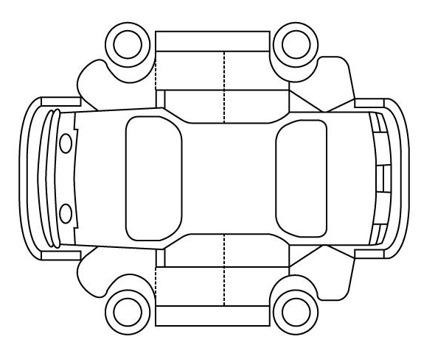
Task: |  | Complete | Action Items
Vehicle at Ground Level
Check exterior paint condition and show faults on vehicle body report
Check operation of all doors, bonnet and boot/hatch
Check operation of central locking on all doors
Check operation of all exterior lights
Check for spare wheel and vehicle jack
Check tyre pressures and wheel nut torque
Interior
Check operation of driver warning lights
Check operation of interior lights
Check operation of all driver controls
Check operation of entertainment system
Check operation of all windows
Check operation of foot and parking brake
Check security and operation of seat belts
Under Bonnet
Check engine oil, coolant windscreen washer, brake fluid levels
Check for oil, fuel and coolant leaks
Check battery connections
Vehicle Raised on Hoist
Check exhaust for security and leaks
Check transmission fluid levels
Visually check brakes, steering and suspension for loose parts
Final Inspection
Body free from protective film
Windows clean
Garage sticker in rear window
Action items reported

Unit 11 (D/501/7018) | Assessment Criteria 3.3 | Task No 11.3

Task: Used Vehicle Inspection

Vehicle Details
Make | Model | Year

Instructions to Learners

Following the checklist on the next page, carry out a used vehicle inspection noting any findings

Assessor Checklist | Achieved  Y/N
PPE selected and correctly used
Methodical Procedures used
Checklist completed

Assessor Declaration
In signing this sheet the assessor and learner confirm that all the operations in this task were carried out by the named learner and the learner observed safe working practices at all times.

Assessor Signature……………………………………………………............ Date………………………..

Learner Signature.………………………………………………………..……….. Date………………………..

NEW VEHICLE INSPECTION CHECKLIST

Vehicle Details | Vehicle Body Report
Make________________________

Model________________________

Year_________________________

Colour_______________________

Task: |  | Complete | Action Items
Vehicle at Ground Level
Check exterior paint condition and show faults on vehicle body report
Check operation of all doors, bonnet and boot/hatch
Check operation of central locking on all doors
Check operation of vehicle security system
Check operation of all exterior lights
Check tyre tread depth including spare
Check tyre pressures and wheel nut torque
Interior
Check operation of driver warning lights
Check operation of interior lights
Check operation of all driver controls
Check operation of entertainment system
Check operation of all windows
Check operation of foot and parking brake
Check security and operation of seat belts
Check condition of interior trim
Under Bonnet
Check engine oil, coolant windscreen washer, brake fluid levels
Check for oil, fuel and coolant leaks
Start engine and check for abnormal noises
Vehicle Raised on Hoist
Check exhaust for security and leaks
Check transmission fluid levels
Check steering and suspension for wear
Visually check fuel and brake pipes for corrosion
Check vehicle underbody for damage and corrosion
Final Inspection
Mot current
Tax current
Garage sticker in rear window
Action items reported

UNIT 12 (H/501/7019)
INTRODUCTION TO VEHICLE BODY REPAIR

ASSESSMENT CRITERIA RECORD

Specification Reference | Assessment  Criteria | Evidence  Reference*
1. Work safely | 1.1 Use safe working practices when undertaking routine vehicle body repairs | All Jobcards
2. Know about engineering materials used in body repair | 2.1 Identify vehicle body components manufactured from:  - Steel  - Alloy steel  - Non-ferrous metals  - Thermo setting plastic materials  - Thermo plastic materials  - Glass  2.2 Identify anti-corrosive materials | 12.1  12.1
3. Know about body damage to vehicles panels | 3.1 Give examples of body damage to vehicle panels  3.2 Identify body damage that requires professional repair  3.3 Give examples of body damage that can be rectified by non-professionals | 12.2  12.2  12.2
4. Know how to use appropriate tools, materials and techniques for minor body repair | 4.1 Select and use panel beating tools to repair minor vehicle body damage (hammers, dollies, etc.)  4.2 Repair a damaged vehicle panel using plastic filler to achieve the correct contour | 12.3  12.3
5. Know how to remove and refit body components | 5.1 Remove and refit a vehicle door and one of the following body components:  - bonnet  - boot  - hatch lid  5.2 Remove and refit front and rear plastic bumpers | 12.4  12.5
6. Know about welding techniques | 6.1 Produce a spot weld lap joint  6.2 Perform a destructive test on a spot weld  6.3 Remove a spot weld with an appropriate tool or drill bit  6.4 Replace a spot weld with a MIG plug | 12.6

* Where evidence is provided through responses to underpinning knowledge tests, a copy of the responses must be included as part of the evidence. An evidence reference should be added to the column.

ASSESSOR FEEDBACK ON UNIT COMPLETION
This confirms unit completion and should offer supportive guidance to the learner

Unit 12 (H/501/7019) | Assessment Criteria 2.1 & 2.2 | Task No 12.1

Task: Identify Body Materials

Instructions to learners
By inspecting a vehicle body structure, identify components manufactured from the materials listed below.
Material | Body Component
Steel | 1.
Steel | 2.
Alloy Steel | 1.
Alloy Steel | 2.
Non-Ferrous Metal | 1.
Non-Ferrous Metal | 2.
Thermo-Setting Plastic | 1.
Thermo-Setting Plastic | 2.
Thermo Plastic | 1.
Thermo Plastic | 2.
Glass | 1.
Glass | 2.
Anti-Corrosive Material | 1.
Anti-Corrosive Material | 2.

Assessor Checklist | Achieved  Y/N
PPE selected and correctly used
Methodical Procedures used
Table completed

Assessor Declaration
In signing this sheet the assessor and learner confirm that all the operations in this task were carried out by the named learner and the learner observed safe working practices at all times.

Assessor Signature……………………………………………………............ Date………………………..

Learner Signature.………………………………………………………..……….. Date………………………..

Unit 12 (H/501/7019) | Assessment Criteria 3.1, 3.2 & 3.3 | Task No 12.2

Task: Identify Body Damage

Instructions to learners
1. The table below lists possible damage and the panels affected.

2. Complete the table to include who would carry out the specific repair and indicate whether a body alignment check is required.

The first one has been completed as an example.
Condition | Panel | Who will carry out the repair? | Body alignment check required
Condition | Panel | Who will carry out the repair? | Yes () | No (x)
Paint Flaking | Rear Wheel Arch | Paint Technician |  | x
Dent | Bolt-on Wing
Crease | Door Panel
Accident Damage | Inner Wing Panel
Cosmetic Corrosion | Bonnet
Crease | Chassis Leg
Metal Crushed | Sill
Scratch | Tailgate
Accident Damage | Bulkhead

Assessor Checklist | Achieved  Y/N
PPE selected and correctly used
Methodical Procedures used
Table completed with reasons

Assessor Declaration
In signing this sheet the assessor and learner confirm that all the operations in this task were carried out by the named learner and the learner observed safe working practices at all times.

Assessor Signature……………………………………………………............ Date………………………..

Learner Signature.………………………………………………………..……….. Date………………………..

Unit 12 (H/501/7019) | Assessment Criteria 4.1 & 4.2 | Task No 12.3

Task: Repair Minor Body Damage

Instructions to Learners
- Cold shrink stretched area of metal panel
- Mix suitable amount of polyester filler
- Smooth filler to obtain correct shape and feather edge of repair

Tool List | Materials List
Hand Tools | Abrasives
1. | 1.
2. | 2.
Power Tools | Polyester Filler Mix Ratio
1. | Filler%
2. | Hardener %

Assessor Checklist | Achieved  Y/N
PPE selected and correctly used
Methodical Procedures used
Tools and materials list completed

Assessor Declaration
In signing this sheet the assessor and learner confirm that all the operations in this task were carried out by the named learner and the learner observed safe working practices at all times.

Assessor Signature……………………………………………………............ Date………………………..

Learner Signature.………………………………………………………..……….. Date………………………..

Unit 12 (H/501/7019) | Assessment Criteria 5.1 | Task No 12.4

Task: Remove and Refit Body Components

Tool List | Materials List

Instructions to Learners
1. Select door to be removed
2. Disconnect electrical items
3. Support door prior to removal
4. Remove door and store securely
5. Refit door and electrical connections
6. Adjust door to ensure correct gaps, swage lines and ensure panel flush to adjacent panel
7. Check door catch and electrical components for correct operation
8. Select another component to be removed from. (Circle component selected below)

Bonnet Boot Hatch Lid

9. Protect adjacent panels from damage
10. Disconnect electrical or other items
11. Remove Component and store securely
12. Refit component and electrical or other items
13. Adjust component for correct gaps and operation
14. Check component catch and electrical components for correct operation

Assessor Checklist | Achieved  Y/N
PPE selected and correctly used
Methodical Procedures used
Alignment checked
Electrical components operate

Assessor Declaration
In signing this sheet the assessor and learner confirm that all the operations in this task were carried out by the named learner and the learner observed safe working practices at all times.

Assessor Signature……………………………………………………............ Date………………………..

Learner Signature.………………………………………………………..……….. Date………………………..

Unit 12 (H/501/7019) | Assessment Criteria 5.2 | Task No 12.5

Task: Remove and Refit Body Components

Vehicle Details | Special Tools
Make________________________________

Model_______________________________

Year________________________________

Colour_______________________________

Instructions to Learners
1. Obtain manufacturers or other information on fixing methods and location
2. Using correct procedure, remove a FRONT plastic bumper
3. Refit bumper ensuring correct fixing and alignment
4. Using correct procedure, remove a REAR plastic bumper
5. Refit bumper ensuring correct fixing and alignment

Assessor Checklist | Achieved  Y/N
PPE selected and correctly used
Methodical Procedures used
Alignment checked

Assessor Declaration
In signing this sheet the assessor and learner confirm that all the operations in this task were carried out by the named learner and the learner observed safe working practices at all times.

Assessor Signature……………………………………………………............ Date………………………..

Learner Signature.………………………………………………………..……….. Date………………………..

Unit 12 (H/501/7019) | Assessment Criteria 6.1, 6.2, 6.3 & 6.4 | Task No 12.6

Task: Spot and MIG/MAG Welding

Tool List | Safety Equipment | Materials List

Instructions to Learners  SPOT WELDING  - Select and prepare the material to receive spot weld lap joint  2. Select machine settings appropriate to material selected  3. Carry out spot weld, observing appropriate safety precautions  4. Carry out sheer and peel test on spot weld and report findings  MIG PLUG WELDING  1. Carry out second spot weld adjusting settings as required  2. Remove spot weld with cobalt drill to receive MIG/MAGplug  3. Select MIG/MAG machine settings appropriate to the material used  4. Carry out MIG/MAG plug weld, observing appropriate Safety precautions. | Destructive Test Report
_____________________
_____________________
_____________________
_____________________
_____________________
_____________________
_____________________
_____________________
_____________________
_____________________
_____________________
_____________________

Assessor Checklist | Achieved  Y/N
PPE selected and correctly used
Methodical Procedures used
Tools and materials list completed

Assessor Declaration
In signing this sheet the assessor and learner confirm that all the operations in this task were carried out by the named learner and the learner observed safe working practices at all times.

Assessor Signature……………………………………………………............ Date………………………..

Learner Signature.………………………………………………………..……….. Date………………………..

UNIT 13 (Y/501/7020)
INTRODUCTION TO VEHICLE REFINISHING

ASSESSMENT CRITERIA RECORD

Specification Reference | Assessment  Criteria | Evidence  Reference*
1. Work safely | 1.1 Use safe working practices when undertaking vehicle refinishing | All Jobcards
2. Know about surface preparation | 2.1 Select and use abrasives to prepare various substrates for the next operation  2.2 Demonstrate the safe use of power equipment with particular attention to correct PPE | 13.1
3. Understand the procedure for bodywork preparation prior to refinishing | 3.1 Identify substrate to be refinished  3.2 Demonstrate the correct methods and stages of surface preparation  3.3 Demonstrate the correct methods of masking paintwork for the refinishing operation | 13.1
4. Know how to mix and apply primers | 4.1 Demonstrate the correct methods of preparing a range of primers for use  4.2 Demonstrate the correct and safe methods of painting with primer/s to an acceptable standard  4.3 Prepare primed surface to accept top coat | 13.2
5. Know how to apply a top coat | 5.1 Demonstrate the correct methods of preparing a range of top coats and application equipment for use  5.2 Demonstrate the correct safe method of painting panels with top coat  5.3 Demonstrate the correct and safe method of servicing equipment after use with the above painting techniques | 13.3
6. Know how to identify and correct basic paint defects | 6.1 Identify basic paint defects  6.2 Identify cause and rectification of paint defects | 13.4
7. Know how to enhance paint finishes | 7.1 Demonstrate the correct procedure for compounding, machine or hand glazing  7.2 Apply polishes to protect the refinished surface | 13.5

* Where evidence is provided through responses to underpinning knowledge tests, a copy of the responses must be included as part of the evidence. An evidence reference should be added to the column.

ASSESSOR FEEDBACK ON UNIT COMPLETION
This confirms unit completion and should offer supportive guidance to the learner

Unit 13 (Y/501/7020) | Assessment Criteria 2.1, 2.2, 3.1, 3.2 & 3.3 | Task No 13.1

Task: Prepare Surface for Painting

Tool List | Safety Equipment | Materials List
Power Tools |  | Abrasives
1. |  | 1.
2. |  | 2.
Hand Tools |  | Substrate Identification
Instructions to Learners
1. Identify the substrate to be painted
2. Select and use appropriate abrasives to prepare the surface to receive primer
3. Mask prepared area as appropriate

Assessor Checklist | Achieved  Y/N
PPE selected and correctly used
Methodical Procedures used
Tools and materials list completed
Safety equipment listed

Assessor Declaration
In signing this sheet the assessor and learner confirm that all the operations in this task were carried out by the named learner and the learner observed safe working practices at all times.

Assessor Signature……………………………………………………............ Date………………………..

Learner Signature.………………………………………………………..……….. Date………………………..

Unit 13 (Y/501/7020) | Assessment Criteria 4.1, 4.2, 4.3 | Task No 13.2

Task: Application of Primers

Tool List | Safety Equipment | Materials List
Power Tools |  | Abrasives
1. |  | 1.
2. |  | 2.
Hand Tools |  | Substrate Identification
Instructions to Learners
1. Select and use appropriate abrasives and cleaners to prepare the surface to receive primer
2. Apply primer to surface to industry acceptable standard and using industry acceptable equipment whilst conforming to all health and safety legislation
3. Clean and service the paint application equipment to an acceptable standard and following health and safety and COSHH legislation.

Assessor Checklist | Achieved  Y/N
PPE selected and correctly used
Methodical Procedures used
Tools and materials list completed
Safety equipment listed

Assessor Declaration
In signing this sheet the assessor and learner confirm that all the operations in this task were carried out by the named learner and the learner observed safe working practices at all times.

Assessor Signature……………………………………………………............ Date………………………..

Learner Signature.………………………………………………………..……….. Date………………………..

Unit 13 (Y/501/7020) | Assessment Criteria 5.1, 5.2 & 5.3 | Task No 13.3

Task: Application of Top Coat

Tool List | Safety Equipment | Materials List
Power Tools |  | Abrasives
1. |  | 1.
2. |  | 2.
 |  | Substrate Identification
Instructions to Learners
1. Select and use appropriate abrasives and cleaners to prepare the surface to receive top-coat
2. Select and use appropriate abrasives and cleaners to prepare the surface to receive primer
3. Apply top-coat to surface to industry acceptable standard and using industry acceptable equipment whilst conforming to all health and safety legislation
4. Clean the paint application equipment to an acceptable standard and following health and safety and COSHH legislation

Assessor Checklist | Achieved  Y/N
PPE selected and correctly used
Methodical Procedures used
Tools and materials list completed
Safety equipment listed

Assessor Declaration
In signing this sheet the assessor and learner confirm that all the operations in this task were carried out by the named learner and the learner observed safe working practices at all times.

Assessor Signature……………………………………………………............ Date………………………..

Learner Signature.………………………………………………………..……….. Date………………………..

Unit 13 (Y/501/7020) | Assessment Criteria 6.1 & 6.2 | Task No 13.4

Task: Application of Top Coat

Instructions to Learners

- Use a previously painted panel to identify the paint defects listed below:
- Complete the table by entering the cause and rectification procedure for each defect.

Paint Defect | Cause | Rectification
Runs
Orange Peel
Dirt Inclusion
Sanding Marks
Poor Opacity
Crazing/Cracking

Assessor Checklist | Achieved  Y/N
Correct cause identified
Correct rectification

Assessor Declaration
In signing this sheet the assessor and learner confirm that all the operations in this task were carried out by the named learner and the learner observed safe working practices at all times.

Assessor Signature……………………………………………………............ Date………………………..

Learner Signature.………………………………………………………..……….. Date………………………..

Unit 13 (Y/501/7020) | Assessment Criteria 7.1 & 7.2 | Task No 13.5

Task: Compounding a newly painted panel

Tool List | Safety Equipment | Materials List
 |  | 1.
 |  | 2.
 |  | Paint Identification
Instructions to Learners
1. Select a surface that has recently been painted with top-coat
2. Identify the paint applied
3. Select and use the appropriate equipment and materials to compound the surface
4. Apply appropriate surface protection to industry acceptable standard

Assessor Checklist | Achieved  Y/N
PPE selected and correctly used
Methodical Procedures used
Tools and materials list completed
Safety equipment listed

Assessor Declaration
In signing this sheet the assessor and learner confirm that all the operations in this task were carried out by the named learner and the learner observed safe working practices at all times.

Assessor Signature……………………………………………………............ Date………………………..

Learner Signature.………………………………………………………..……….. Date………………………..

UNIT 14 (D/501/7021)
INTRODUCTION TO CUSTOMER CARE

ASSESSMENT CRITERIA RECORD

Specification Reference | Assessment  Criteria | Evidence  Reference*
1. Recognise the elements of positive customer experience | 1.1 Give an example of a positive customer experience  1.2 Give an example of a negative customer experience | 14.1
2. Understand the importance of the customer’s experience to a business | 2.1 Indicate how positive and negative customer experience could affect a business | 14.1
3. Recognise own contribution to customer experience | 3.1 Identify and demonstrate behaviors that would contribute to a positive customer experience when:  - greeting a customer  - answering customer questions  - relaying customer information or requests to the correct workplace person  3.2 Identify and demonstrate behaviors that would contribute to a negative customer experience when:  - greeting a customer  - answering customer questions  - relaying customer information or requests to the correct workplace person | 14.1  14.2  14.1  14.2
4. Know how to promote customer safety | 4.1 Identify and demonstrate customer safety procedures | 14.3

* Where evidence is provided through responses to underpinning knowledge tests, a copy of the responses must be included as part of the evidence. An evidence reference should be added to the column.

ASSESSOR FEEDBACK ON UNIT COMPLETION
This confirms unit completion and should offer supportive guidance to the learner

Unit 14 (D/501/7021) | Assessment Criteria 1.1, 1.2, 2.1, 3.1(Part) 3.2(Part) | Task No 14.1

Task: Examples of Customer Experience

Instructions to Learners
Below are three case studies of dealing with customers.
1. In each case state how you would deal with the situation ensuring a POSITIVE customer experience
2. In each case state the behavior that would result in a NEGATIVE customer experience and how this might affect the business
Case Study 1
It is 4.00 o’clock in the afternoon and you have been asked to inquire what a male customer in reception requires. How would you introduce yourself?

Positive Customer Experience

……………………………………………………………………………………………………………………

…………………………………………………………………………………………………………………..
Negative Customer Experience

……………………………………………………………………………………………………………………

……………………………………………………………………………………………………………………

Effect on Business

…………………………………………………………………………………………………………………….

…………………………………………………………………………………………………………………….

Case Study 2
The manager of the company has asked you to ask a female customer standing in the workshop if she will wait in the customer reception area. How would you do this?
Positive Customer Experience

……………………………………………………………………………………………………………………

…………………………………………………………………………………………………………………..
Negative Customer Experience

……………………………………………………………………………………………………………………

……………………………………………………………………………………………………………………
Effect on Business

…………………………………………………………………………………………………………………….

…………………………………………………………………………………………………………………….
Case Study 3
A male customer has been waiting in the reception area for about an hour, he asks you how much longer it will take to repair his vehicle. How would you answer him and what would you do?
Positive Customer Experience

……………………………………………………………………………………………………………………

…………………………………………………………………………………………………………………..
Negative Customer Experience

……………………………………………………………………………………………………………………

……………………………………………………………………………………………………………………
Effect on Business

…………………………………………………………………………………………………………………….

…………………………………………………………………………………………………………………….

Assessor Checklist | Achieved  Y/N
Case Studies answered correctly
Example of poor practice is feasible
Effect on business is meaningful

Assessor Declaration
In signing this sheet the assessor and learner confirm that all the operations in this task were carried out by the named learner and the learner observed safe working practices at all times.

Assessor Signature……………………………………………………............ Date………………………..

Learner Signature.………………………………………………………..……….. Date………………………..

Unit 14 (D/501/7021) | Assessment Criteria 3.1 & 3.2 | Task No 14.2

Task: Dealing with Customers

Instructions to Learners
You are required to demonstrate good customer care by dealing direct with customers in a variety of situations. You will be observed by your assessor in each case
Instructions to the Assessor
You are to observe the learner dealing with customers and are required to complete and sign the observation sheets below.

1. Learner Greets Customer
Situation

………………………………………………………………………………………………………………………………….

Assessor Report

………………………………………………………………………………………………………………………………….

………………………………………………………………………………………………………………………………….

……………………………………………………………………………………………………………………............

Assessor Signature…………………………………………………….............. Date………………………………

2. Learner Answers Customer Question
Situation

………………………………………………………………………………………………………………………………….

Assessor Report

………………………………………………………………………………………………………………………………….

………………………………………………………………………………………………………………………………….

……………………………………………………………………………………………………………………............

Assessor Signature…………………………………………………….............. Date………………………………

3. Learner Relays Customer Information or requests to Correct Workplace Person
Situation

………………………………………………………………………………………………………………………………….

Assessor Report

………………………………………………………………………………………………………………………………….

………………………………………………………………………………………………………………………………….

……………………………………………………………………………………………………………………............

Assessor Signature…………………………………………………….............. Date………………………………

Unit 14 (D/501/7021) | Assessment Criteria 4.1 | Task No 14.3

Task: Examples of Customer Experience

Instructions to Learners
Any Motor Vehicle repair establishment can present hazards to safety by the nature of the work involved.

Customers may not be aware of these hazards and so it is important to identify customer safety procedures

Complete the table below listing THREE safety hazards and THREE methods of ensuring customer safety whilst visiting a motor vehicle repair establishment.

Hazard | Method
1. | 1.
2. | 2.
3. | 3.

Assessor Checklist | Achieved  Y/N
Case Studies answered correctly
Example of poor practice is feasible
Effect on business is meaningful

Assessor Declaration
In signing this sheet the assessor and learner confirm that all the operations in this task were carried out by the named learner and the learner observed safe working practices at all times.

Assessor Signature……………………………………………………............ Date………………………..

Learner Signature.………………………………………………………..……….. Date………………………..

UNIT 15 (H/501/7022)
INTRODUCTION TO VEHICLE WHEELS AND TYRES

ASSESSMENT CRITERIA RECORD

Specification Reference | Assessment  Criteria | Evidence  Reference*
1. Work safely | 1.1 Use safe working practices when working with wheels and tyres | All Jobcards
2. Know how to remove and replace road wheels | 2.1 Remove and replace road wheels with special attention to  - Safe jacking procedure  - Use of correct jacking points  - Use of axle stands  Use of torque wrench | 15.1
3. Know how to inspect road wheels | 3.1 Give examples of common wheel faults  3.2 Perform visual inspection of road wheels for serviceability with particular attention to damage and attachment devices  3.3 Identify key findings of inspection | 15.1
4. Know about tyre maintenance | 4.1 Using methodical procedures, carry out routine tyre maintenance with regard to:  - Checking and adjusting tyre pressures  - Measuring tread depth  - Removing inclusions from tread area  - Inspecting sidewalls for damage  4.2 Identify from samples common tyre faults | 15.1  15.2
5. Know how to replace tyres | 5.1 Remove a tyre (including valve assembly where appropriate) from a road wheel  5.2 Identify the correct replacement tyre for a specified vehicle  5.3 Fit a tyre in accordance with manufacturers guidance  5.4 Re-inflate to correct pressure | 15.3
6. Know how to balance wheels | 6.1 Explain the purpose of balancing a wheel and tyre assembly  6.2 Balance a wheel and tyre assembly in accordance with manufacturers guidance | 15.3
7. Be aware of environmental considerations | 7.1 Demonstrate appropriate ways to dispose of waste products in accordance with environmental guidance | 15.4

* Where evidence is provided through responses to underpinning knowledge tests, a copy of the responses must be included as part of the evidence. An evidence reference should be added to the column.

ASSESSOR FEEDBACK ON UNIT COMPLETION
This confirms unit completion and should offer supportive guidance to the learner

Unit 15 (H/501/7022) | Assessment Criteria 2.1, 3.1, 3.2, 3.3 & 4.1 | Task No 15.1

Task: Remove and Replace Road Wheel

Vehicle Details | Special Tools | Data
Make_______________  Model_______________  Year________________ |  | Tyre Size
 |  | Wheel Condition
 |  | Tyre Wear
 |  | Tread Depth
 |  | Minimum Legal Tread Depth
 |  | Wheel Nut Torque

Assessor Checklist | Achieved  Y/N
PPE selected and used correctly
Methodical Procedures used
Data completed

Assessor Declaration
In signing this sheet the assessor and learner confirm that all the operations in this task were carried out by the named learner and the learner observed safe working practices at all times.

Assessor Signature……………………………………………………............ Date………………………..

Learner Signature.………………………………………………………..……….. Date………………………..

Unit 15 (H/501/7022) | Assessment Criteria 4.2 | Task No 15.2

Task: Identify Common Tyre Faults

Instructions to Learners

1. Using the diagrams below, identify the faults suggested and give possible causes for each
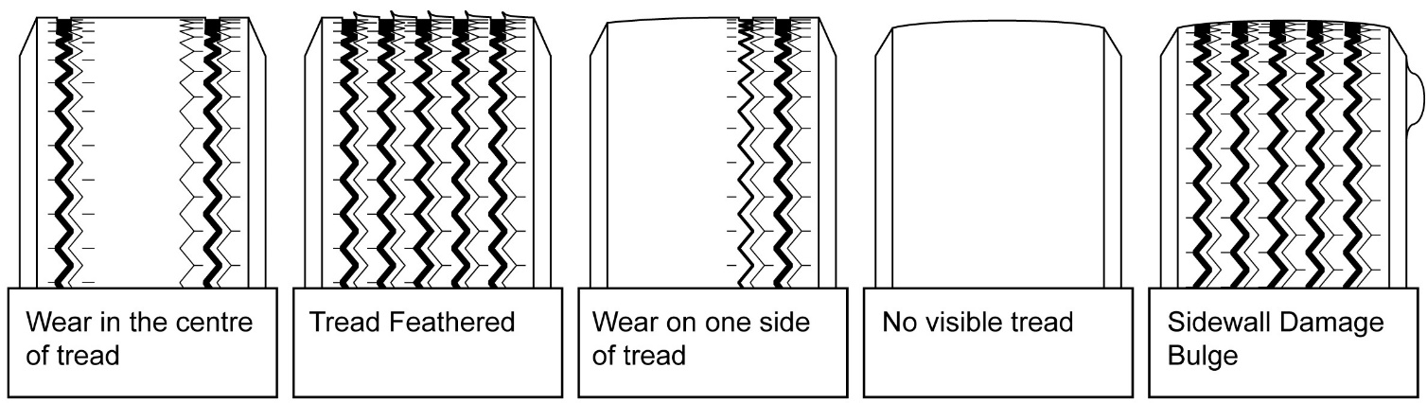
Symptom | Cause | Legal (Yes/No)
Wear in centre of tread
Tread feathered
Wear on one side of tread
No Visible tread
Sidewall damaged

Assessor Checklist | Achieved  Y/N
PPE selected and used correctly
Methodical Procedures used
Data completed

Assessor Declaration
In signing this sheet the assessor and learner confirm that all the operations in this task were carried out by the named learner and the learner observed safe working practices at all times.

Assessor Signature……………………………………………………............ Date………………………..

Learner Signature.………………………………………………………..……….. Date………………………..

Unit 15 (H/501/7022) | Assessment Criteria 5.1, 5.2, 5.3, 5.4, 6.2 | Task No 15.3

Task: Change a Vehicle Tyre Balance a Vehicle Road Wheel

Vehicle Details | Special Tools | Data
Make_______________  Model_______________  Year________________ |  | Tyre Inflation Pressure
 |  | Rim Weights
Instructions to Learners
- Deflate tyre safely
- Mount on tyre machine and remove tyre
- Inspect wheel for serviceability
- Identify correct replacement tyre
- Fit replacement tyre to wheel
- Inflate to correct pressure
- Mount wheel/tyre assembly onto balancing machine
- Following the machine manufacturer’s instructions check the wheel assembly for dynamic and static balance
- Balance wheel following machine instructions

Assessor Checklist | Achieved  Y/N
PPE selected and used correctly
Methodical Procedures used
Data completed

Assessor Declaration
In signing this sheet the assessor and learner confirm that all the operations in this task were carried out by the named learner and the learner observed safe working practices at all times.

Assessor Signature……………………………………………………............ Date………………………..

Learner Signature.………………………………………………………..……….. Date………………………..

Unit 15 (H/501/7022) | Assessment Criteria 7.1 | Task No 15.4

Task: Waste Disposal

Instructions to Learners
State in the spaces provided below the correct procedure for disposing of waste wheel and tyre components IN YOUR WORKSHOP
Component | Correct Disposal
Tyres
Wheels

Assessor Checklist | Achieved  Y/N
PPE selected and used correctly
Methodical Procedures used
Report completed

Assessor Declaration
In signing this sheet the assessor and learner confirm that all the operations in this task were carried out by the named learner and the learner observed safe working practices at all times.

Assessor Signature……………………………………………………............ Date………………………..

Learner Signature.………………………………………………………..……….. Date………………………..

UNIT 16 (M/501/7024)
INTRODUCTION TO VEHICLE EXHAUST SYSTEMS

ASSESSMENT CRITERIA RECORD

Specification Reference | Assessment  Criteria | Evidence  Reference*
1. Work safely | 1.1 Use safe working practices when working with vehicle exhaust systems | All Jobcards
2. Know the main components of a vehicle exhaust system | 2.1 Identify and locate the main components of a vehicle exhaust system to include:  - Manifold  - Catalytic converter  - Oxygen sensor  - Front pipe  - Silencer | 16.1
3. Know how to inspect a vehicle exhaust system | 3.1 Give examples of common exhaust faults  3.2 Perform visual inspection of exhaust system for serviceability with particular attention to leakage, corrosion, damage and security  3.3 Identify key findings of inspection | 16.2
4. Know how to replace a vehicle exhaust component | 4.1 Remove an exhaust component  4.2 Identify the correct replacement component for a specified vehicle  4.3 Fit an exhaust component in accordance with manufacturers guidance  4.4 Perform inspection to ensure correct alignment, security and sealing | 16.3
5. Be aware of environmental considerations | 5.1 Demonstrate appropriate ways to dispose of waste products in accordance with environmental guidance | 16.4

* Where evidence is provided through responses to underpinning knowledge tests, a copy of the responses must be included as part of the evidence. An evidence reference should be added to the column.

ASSESSOR FEEDBACK ON UNIT COMPLETION
This confirms unit completion and should offer supportive guidance to the learner

Unit 16 (M/501/7024) | Assessment Criteria 2.1 | Task No 16.1

Task: Identify Exhaust Components

Instructions to Learners
1. Examine an exhaust system on a vehicle and compare to the diagram below.
2. Identify the components numbered on the diagram and complete the table.

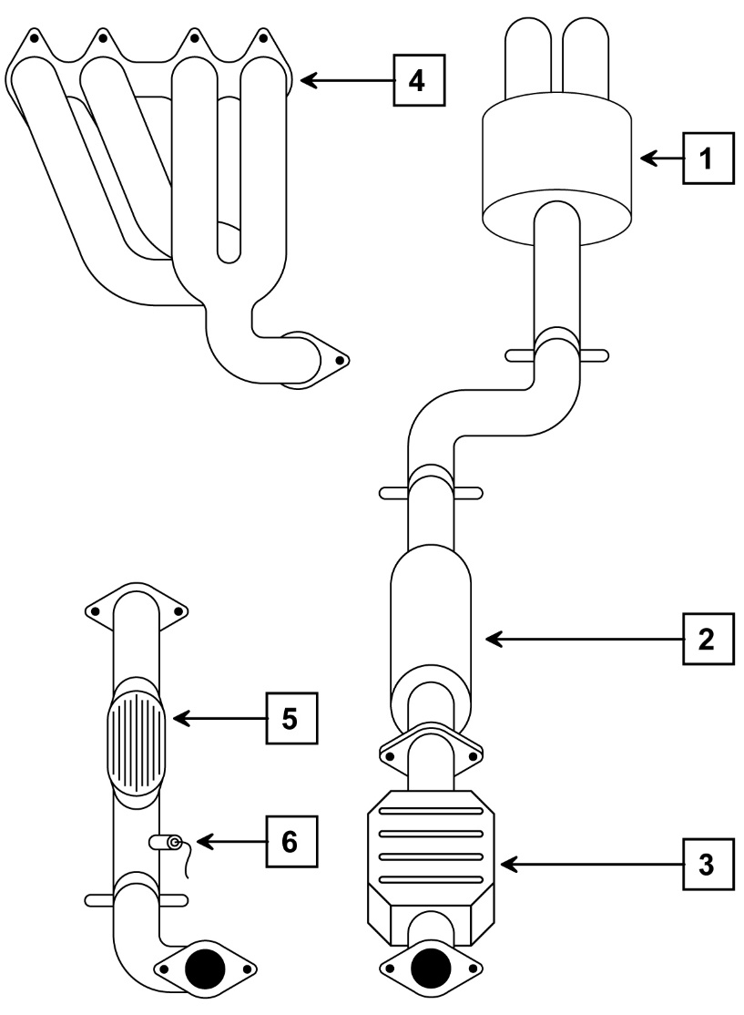
Number | Component
 | Manifold
 | Front Pipe
 | Oxygen Sensor
 | Middle Silencer
 | Catalytic Converter
 | Rear Silencer

Assessor Checklist | Achieved  Y/N
PPE selected and used correctly
Methodical Procedures used
Components correctly identified

Assessor Declaration
In signing this sheet the assessor and learner confirm that all the operations in this task were carried out by the named learner and the learner observed safe working practices at all times.

Assessor Signature……………………………………………………............ Date………………………..

Learner Signature.………………………………………………………..……….. Date………………………..

Unit 16 (M/501/7024) | Assessment Criteria 3.1, 3.2, 3.3 | Task No 16.2

Task: Exhaust System Inspection

Instructions to Learners
1. Examine a vehicle exhaust system for faults
2. Complete the inspection report noting findings.
Exhaust Condition Report
Component | Leakage | Corrosion | Damage | Security
Manifold
Exhaust Pipes
Silencers
Support Brackets
Catalytic Converter

Assessor Checklist | Achieved  Y/N
PPE selected and used correctly
Methodical Procedures used
Report completed

Assessor Declaration
In signing this sheet the assessor and learner confirm that all the operations in this task were carried out by the named learner and the learner observed safe working practices at all times.

Assessor Signature……………………………………………………............ Date………………………..

Learner Signature.………………………………………………………..……….. Date………………………..

Unit 16 (M/501/7024) | Assessment Criteria 4.1, 4.2, 4.3 & 4.4 | Task No 16.3

Task: Replace Exhaust Section

Vehicle Details | Special Tools | Exhaust Section Replaced
Make_______________

Model_______________

Year________________

Instructions to Learners
- Position vehicle at correct working height
- Remove exhaust section and mountings
- Identify correct replacement section
- Replace exhaust section
- Run engine and check for exhaust system leakage and correct positioning

Assessor Checklist | Achieved  Y/N
PPE selected and used correctly
Methodical Procedures used
Data completed

Assessor Declaration
In signing this sheet the assessor and learner confirm that all the operations in this task were carried out by the named learner and the learner observed safe working practices at all times.

Assessor Signature……………………………………………………............ Date………………………..

Learner Signature.………………………………………………………..……….. Date………………………..

Unit 16 (M/501/7024) | Assessment Criteria 5.1 | Task No 16.4

Task: Waste Disposal

Instructions to Learners
State in the spaces provided below the correct procedure for disposing of waste exhaust components

Component | Correct Disposal
Exhaust Pipes
Catalytic Converter
Rubber Mountings
Exhaust Silencers

Assessor Checklist | Achieved  Y/N
PPE selected and used correctly
Methodical Procedures used
Report completed

Assessor Declaration
In signing this sheet the assessor and learner confirm that all the operations in this task were carried out by the named learner and the learner observed safe working practices at all times.

Assessor Signature……………………………………………………............ Date………………………..

Learner Signature.………………………………………………………..……….. Date………………………..

UNIT 17 (A/501/7026)
INTRODUCTION TO VEHICLE IGNITION SYSTEMS

ASSESSMENT CRITERIA RECORD

Specification Reference | Assessment  Criteria | Evidence  Reference*
1. Work safely | 1.1 Use safe working practices when working with vehicle ignition systems  1.2 Identify and avoid specific risks associated with high tension systems | All Jobcards
2. Know the main components of a vehicle ignition system | 2.1 Identify and locate the main components of a vehicle ignition system to include:  - Ignition coils  - Spark plug leads  - Spark plugs  2.2 Identify the primary purpose of each | 17.1
3. Know how to replace a vehicle ignition component | 3.1 Remove and replace an ignition coil  3.2 Remove, inspect and measure the resistance of an HT lead using correct equipment  3.3 Replace the HT lead in the correct position  3.4 Remove and examine spark plugs to identify signs of wear  3.5 Replace spark plugs in accordance with manufacturers’ guidance  3.6 Start engine to check correct engine operation and throttle response | 17.2  17.2  17.2  17.3  17.3  17.2, 17.3
4. Be aware of environmental considerations | 4.1 Demonstrate appropriate ways to dispose of waste products in accordance with environmental guidance | 17.4

* Where evidence is provided through responses to underpinning knowledge tests, a copy of the responses must be included as part of the evidence. An evidence reference should be added to the column.

ASSESSOR FEEDBACK ON UNIT COMPLETION
This confirms unit completion and should offer supportive guidance to the learner

Unit 17 (A/501/7026) | Assessment Criteria 2.1, 2.2 | Task No 17.1

Task: Ignition System Inspection

Instructions to Learners
1. Inspect the ignition system of a modern engine.
2. Identify the arrowed components in the diagram below.
3. Name each component and state the purpose of each
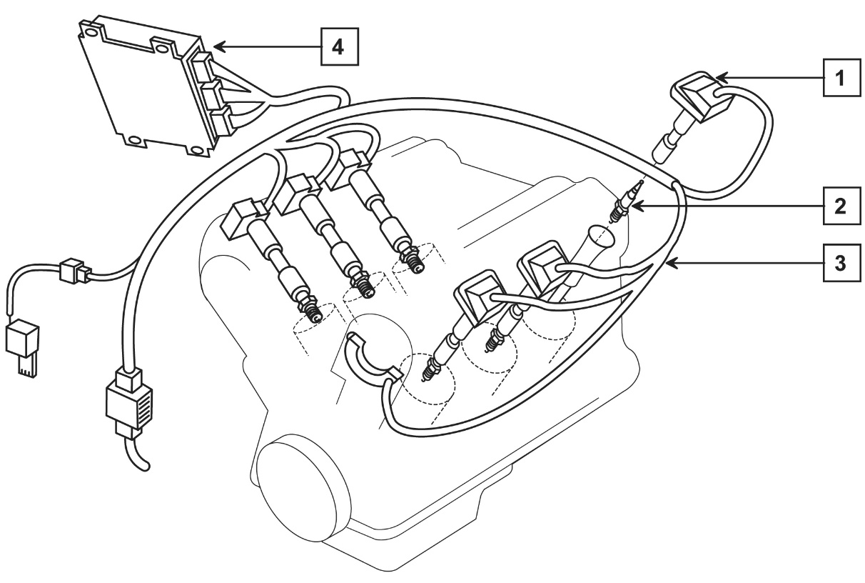
Number | Component | Purpose
1
2
3
4

Assessor Checklist | Achieved  Y/N
PPE selected and used correctly
Methodical Procedures used
Report completed

Assessor Declaration
In signing this sheet the assessor and learner confirm that all the operations in this task were carried out by the named learner and the learner observed safe working practices at all times.

Assessor Signature……………………………………………………............ Date………………………..

Learner Signature.………………………………………………………..……….. Date………………………..

Unit 17 (A/501/7026) | Assessment Criteria 3.1, 3.2, 3.3 & 3.6 | Task No 17.2

Task: Remove and Refit Ignition Coil
Remove and Refit Ignition HT Lead

Vehicle Details | Special Tools | Data
Make_______________  Model_______________  Year________________ |  | Ignition Coil Primary Resistance
 |  | Actual
 |  | Recommended
 |  | HT Lead Resistance
 |  | Actual
 |  | Recommended
Instructions to Learners
1. Locate Ignition Coil
2. Remove Ignition Coil
3. Measure primary winding resistance and report
4. Refit Ignition Coil.
5. Remove HT lead from No.1 spark plug
6. Measure lead resistance and report
7. Refit lead
8. Start engine and check for correct operation and throttle response

NOTE
Ignition HT systems run at very high voltage and care must be taken when working on running engines to avoid electric shocks

Assessor Checklist | Achieved  Y/N
PPE selected and used correctly
Methodical Procedures used
Data completed

Assessor Declaration
In signing this sheet the assessor and learner confirm that all the operations in this task were carried out by the named learner and the learner observed safe working practices at all times.

Assessor Signature……………………………………………………............ Date………………………..

Learner Signature.………………………………………………………..……….. Date………………………..

Unit 17 (A/501/7026) | Assessment Criteria 3.4, 3.5 & 3.6 | Task No 17.3

Task: Remove, Check and Replace Sparking Plug

Vehicle Details | Special Tools | Data
Make_______________  Model_______________  Year________________ |  | Position of No1 sparking plug
 |  | Sparking Plug Make
 |  | Sparking Plug Specification
 |  | Spark Plug Condition
Instructions to Learners
1. Identify number 1 sparking plug
2. Remove No.1 spark plug
3. Check spark plug for condition and report
4. Re-gap as required
5. Refit sparking plug
6. Start engine and check for correct operation and throttle response

Note
Ignition HT systems run at very high voltage and care must be taken when working on running engines to avoid electric shocks

Assessor Checklist | Achieved  Y/N
PPE selected and used correctly
Methodical Procedures used
Data completed

Assessor Declaration
In signing this sheet the assessor and learner confirm that all the operations in this task were carried out by the named learner and the learner observed safe working practices at all times.

Assessor Signature……………………………………………………............ Date………………………..

Learner Signature.………………………………………………………..……….. Date………………………..

Unit 17 (A/501/7026) | Assessment Criteria 4.1 | Task No 17.4

Task: Waste Disposal

Instructions to Learners
State in the spaces provided below the correct procedure for disposing of waste ignition components IN YOUR WORKSHOP

Component | Correct Disposal
Sparking Plugs
Used components

Assessor Checklist | Achieved  Y/N
PPE selected and used correctly
Methodical Procedures used
Data completed

Assessor Declaration
In signing this sheet the assessor and learner confirm that all the operations in this task were carried out by the named learner and the learner observed safe working practices at all times.

Assessor Signature……………………………………………………............ Date………………………..

Learner Signature.………………………………………………………..……….. Date………………………..

UNIT 18 (J/501/7028)
INTRODUCTION TO VEHICLE VALETING

ASSESSMENT CRITERIA RECORD

Specification Reference | Assessment  Criteria | Evidence  Reference*
1. Work safely | 1.1 Use safe working practices when valeting vehicles | All Jobcards
2. Know how to valet the exterior of vehicles | 2.1 Valet vehicle exterior to include:  - Selection and use of appropriate cleaning tools, materials and products for:  - Washing and drying vehicle exterior ensuring removal of dirt, detergent and water  - Restoring surface finish to bodywork, bright work, exterior trim and glass  Protecting surface finish including bodywork, bright work and exterior trim. | 18.1
3. Know how to valet the interior of vehicles | 3.1 Valet vehicle interior to include:  - Selection and use of appropriate cleaning tools, materials and products for:  - Carpets  - Upholstery  - Plastic trim  - Glass | 18.2
4. Know how to valet an engine bay | 4.1 Demonstrate how to protect sensitive electronic components and the air intake prior and during an engine bay valet  4.2 Select and use appropriate cleaning tools, materials, methods and products to clean engine bay | 18.3
5. Know how to inspect a valeted vehicle | 5.1 Perform visual inspection of a valeted vehicle for cleaning residues and surface finish  5.2 Identify key findings of inspection and rectify any imperfections. | 18.4
6. Be aware of environmental considerations | 6.1 Demonstrate appropriate ways to dispose of waste products in accordance with environmental guidance | 18.5

* Where evidence is provided through responses to underpinning knowledge tests, a copy of the responses must be included as part of the evidence. An evidence reference should be added to the column.

ASSESSOR FEEDBACK ON UNIT COMPLETION
This confirms unit completion and should offer supportive guidance to the learner

Unit 18 (J/501/7028) | Assessment Criteria 2.1 | Task No 18.1

Task: Valet Vehicle Exterior

Vehicle Details | Special Tools | Product Data
Make_______________  Model_______________  Year________________  Colour______________ |  | Detergent
 |  | Glass Cleaner
 |  | Paint Renovator
 |  | Paint Polish
 |  | Plastic Restorer
Instructions to Learners
- Wash the vehicle exterior and dry effectively
- Identify paint surface and apply appropriate methods to renovate dull paintwork
- Apply appropriate polish to paintwork
- Clean external glass to ensure no smears are left
- Renovate exterior plastic

Assessor Checklist | Achieved  Y/N
PPE selected and used correctly
Methodical Procedures used
Data completed

Assessor Declaration
In signing this sheet the assessor and learner confirm that all the operations in this task were carried out by the named learner and the learner observed safe working practices at all times.

Assessor Signature……………………………………………………............ Date………………………..

Learner Signature.………………………………………………………..……….. Date………………………..

Unit 18 (J/501/7028) | Assessment Criteria 3.1 | Task No 18.2

Task: Valet Vehicle Interior

Vehicle Details | Special Tools | Product Data
Make_______________  Model_______________  Year________________  Colour______________ |  | Glass Cleaner
 |  | Interior Cleaner
 |  | Plastic Restorer
Instructions to Learners
- Vacuum vehicle interior
- Check upholstery and carpets for soiling and stains
- Select and use appropriate cleaner to remove soiling or stains
- Select and use appropriate polishes to seats. (Leather only)
- Clean interior glass ensuring no smears are left
- Restore the appearance of interior plastic trim

Assessor Checklist | Achieved  Y/N
PPE selected and used correctly
Methodical Procedures used
Data completed

Assessor Declaration
In signing this sheet the assessor and learner confirm that all the operations in this task were carried out by the named learner and the learner observed safe working practices at all times.

Assessor Signature……………………………………………………............ Date………………………..

Learner Signature.………………………………………………………..……….. Date………………………..

Unit 18 (J/501/7028) | Assessment Criteria 4.1 & 4.2 | Task No 18.3

Task: Valet Engine Bay

Vehicle Details | Special Tools |  | Product Data
Make_______________  Model_______________  Year________________  Colour______________ |  |  | Engine Bay Valet Product
Instructions to Learners
1. Identify engine components to be protected prior to engine bay valet and complete the report below
2. Carry out an engine bay valet using appropriate equipment and materials
3. Run engine and check for correct operation and throttle response
4. Remove any residues from the engine bay or surrounding area

Component |  | Method |  | Reason
1.
2.
3.
4.

Assessor Checklist | Achieved  Y/N
PPE selected and used correctly
Methodical Procedures used
Data completed

Assessor Declaration
In signing this sheet the assessor and learner confirm that all the operations in this task were carried out by the named learner and the learner observed safe working practices at all times.

Assessor Signature……………………………………………………............ Date………………………..

Learner Signature.………………………………………………………..……….. Date………………………..

Unit 18 (J/501/7028) | Assessment Criteria 5.1 & 5.2 | Task No 18.4

Task: Vehicle Valet Inspection

Instructions to Learners

1. Inspect a valeted vehicle and indicate key findings in the report below.
2. Outline the rectification procedure required for any imperfections found

Valeting Inspection Report
Condition | O/K (Y/N) | Rectification Required
Exterior
No paintwork Residue
No paintwork polish marks
Door shuts cleaned
No plastic trim residue
No smears on glass
Tops of opening windows cleaned
Interior
Carpets clean and dry
Upholstery clean and dry
No residue on plastic trim
No smears on glass
Tops of opening windows cleaned
Engine Bay
No residue of cleaning product
Component protection removed
No residue in engine bay area

Assessor Checklist | Achieved  Y/N
PPE selected and used correctly
Methodical Procedures used
Report completed

Assessor Declaration
In signing this sheet the assessor and learner confirm that all the operations in this task were carried out by the named learner and the learner observed safe working practices at all times.

Assessor Signature……………………………………………………............ Date………………………..

Learner Signature.………………………………………………………..……….. Date………………………..

Unit 18 (J/501/7028) | Assessment Criteria 6.1 | Task No 18.5

Task: Waste Disposal

Instructions to Learners
State in the spaces provided below the correct procedure for disposing of waste valeting components IN YOUR WORKSHOP

Component | Correct Disposal
Waste Washing Water
Cleaning Product Containers
Used polishing cloths
Waste Water from Engine Bay Valet

Assessor Checklist | Achieved  Y/N
PPE selected and used correctly
Methodical Procedures used
Report completed

Assessor Declaration
In signing this sheet the assessor and learner confirm that all the operations in this task were carried out by the named learner and the learner observed safe working practices at all times.

Assessor Signature……………………………………………………............ Date………………………..

Learner Signature.………………………………………………………..……….. Date………………………..

UNIT 19 (L/501/7029)
INTRODUCTION TO MOTORCYCLE MAINTENANCE

ASSESSMENT CRITERIA RECORD

Specification Reference | Assessment  Criteria | Evidence  Reference*
1. Work safely | 1.1 Use safe working practices when working with motor cycles | All Jobcards
2. Know the main components of the frame assembly | 2.1 Identify the main components of a motor cycle frame assembly | 19.1
3. Know how to disassemble and reassemble major motorcycle components | 3.1 Remove and refit  - body panels  - fairing  - mudguards  3.2 Remove and refit fuel tank taking into account all necessary safety features  3.3 Remove and refit rear damper unit  3.4 Remove and refit a head and barrel assembly  3.5 Perform a visual inspection of a head and barrel assembly to identify signs of excessive wear  3.6 Remove and replace either motor cycle disc pads or brake shoes | 19.2  19.2  19.3  19.4  19.5
4. Know the purpose and operation of safety switches | 4.1 Identify the location and purpose of:  - neutral starter switch  - side stand safety switch  - kill switch  4.2 Check correct operation of each | 19.6
5. Know motorcycle maintenance procedures | 5.1 Carry out straightforward periodic maintenance inspection of:  - tyre pressures and condition  - brake lever travel  - suspensions for leakage and security  - lighting equipment condition and operation  - adjustment of final drive chain or belt  - condition and security of exhaust system  - engine / transmission assembly for oil leakage  - oil and fluid levels.  5.2 Identify key findings of maintenance inspection | 19.7
6. Be aware of environmental considerations | 6.1 Demonstrate appropriate ways to dispose of waste products in accordance with environmental guidance | 19.8

* Where evidence is provided through responses to underpinning knowledge tests, a copy of the responses must be included as part of the evidence. An evidence reference should be added to the column.

ASSESSOR FEEDBACK ON UNIT COMPLETION
This confirms unit completion and should offer supportive guidance to the learner

Unit 19 (L/501/7029) | Assessment Criteria 2.1, 2.2 | Task No 19.1

Task: Motorcycle Components

Instructions to Learners
1. Investigate the layout of a modern motorcycle
2. Complete the table below by identifying the numbered parts on the diagram
Component | Number
Engine
Disc Brake
Drive Chain
Rear Suspension
Exhaust
Fuel tank
Headstock

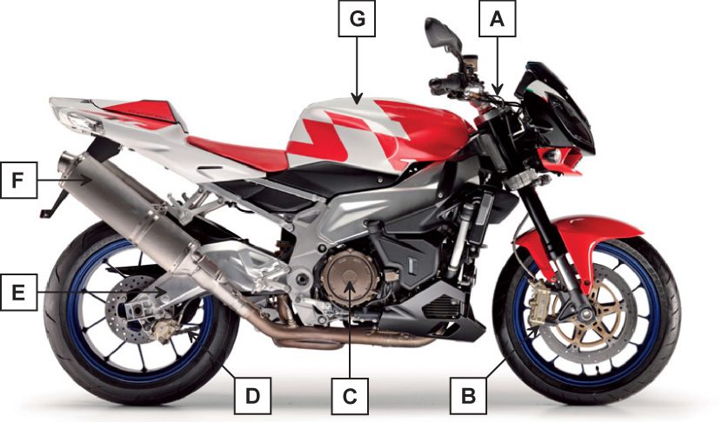

Assessor Checklist | Achieved  Y/N
PPE selected and used correctly
Methodical Procedures used
Report completed

Assessor Declaration
In signing this sheet the assessor and learner confirm that all the operations in this task were carried out by the named learner and the learner observed safe working practices at all times.

Assessor Signature……………………………………………………............ Date………………………..

Learner Signature.………………………………………………………..……….. Date………………………..

Unit 19 (L/501/7029) | Assessment Criteria 3.1, 3.2 | Task No 19.2

Task: Remove and Refit Body Components

Machine Details | Special Tools
Make______________________________

Model_____________________________

Year______________________________

Instructions to Learners

1. Secure Machine
2. Remove each of the following body components
- seat and tank paying particular attention to safety regarding the handling of fuel
- fairings
- front and rear mudguards
3. Refit all panels ensuring correct alignment where required

Assessor Checklist | Achieved  Y/N
PPE selected and used correctly
Methodical Procedures used
Alignment checked

Assessor Declaration
In signing this sheet the assessor and learner confirm that all the operations in this task were carried out by the named learner and the learner observed safe working practices at all times.

Assessor Signature……………………………………………………............ Date………………………..

Learner Signature.………………………………………………………..……….. Date………………………..

Unit 19 (L/501/7029) | Assessment Criteria 3.3 | Task No 19.3

Task: Replace Rear Damper Unit

Machine Details | Special Tools | Fixing Bolt Torque
Make_______________  Model_______________  Year________________ |  | Upper
 |  | Lower
Instructions to Learners

1. Secure machine with rear wheel clear of the ground
2. Remove body panels as required
3. Remove the damper lower fixing
4. Support the damper and remove upper fixing
5. Remove damper, carry out visual checks for leakage/damage, manually check for correct operation
6. Replace damper
7. Adjust damper settings as required

Assessor Checklist | Achieved  Y/N
PPE selected and used correctly
Methodical Procedures used
Data completed

Assessor Declaration
In signing this sheet the assessor and learner confirm that all the operations in this task were carried out by the named learner and the learner observed safe working practices at all times.

Assessor Signature……………………………………………………............ Date………………………..

Learner Signature.………………………………………………………..……….. Date………………………..

Unit 19 (L/501/7029) | Assessment Criteria 3.1 | Task No 19.4

Task: Remove, Examine and Refit Engine Head and Barrel

Machine Details | Special Tools |  | Cylinder Head Torque
Make_______________

Model_______________

Year________________

Instructions to Learners

It is recommended that this task be carried out on a stock single or twin cylinder engine that has been removed from the frame
1. Secure engine prior to dismantling
2. Following manufacturers procedures, remove the cylinder head and barrel.
3. Examine the cylinder head for signs of wear and report findings.
4. Examine barrel for signs of wear and report findings
5. Following manufacturers procedures, refit the barrel and cylinder head.
6. Complete the condition report below
Condition report
Component |  | Condition
Cylinder head
Head surface
Camshaft bearings and tensioners
Valves and springs
Camshaft
Barrel
Bore scoring
Bore wear
Piston ring damage
Piston ring groove wear

Assessor Checklist | Achieved  Y/N
PPE selected and used correctly
Methodical Procedures used
Data completed

Assessor Declaration
In signing this sheet the assessor and learner confirm that all the operations in this task were carried out by the named learner and the learner observed safe working practices at all times.

Assessor Signature……………………………………………………............ Date………………………..

Learner Signature.………………………………………………………..……….. Date………………………..

Unit 19 (L/501/7029) | Assessment Criteria 3.6 | Task No 19.5

Task: Replace Brake Pads or Shoes

Machine Details | Special Tools | Data
Make_______________  Model_______________  Year________________ |  | Type of Braking System  (Disc or Drum)
 |  | Condition Report
 |  | ________________________________________________________________________________________________________________________________________________________________________
Instructions to Learners

1. Secure machine
2. Identify brake system as DISC or DRUM BRAKES
3. Following manufacturers procedure remove EITHER
- Brake Disc Pads
OR
- Brake Shoes
4. Examine pads and disc or shoes and drum for condition
5. Following manufacturers procedure replace pads or shoes.
6. Adjust braking system as required
7. Check braking system for correct operation

Assessor Checklist | Achieved  Y/N
PPE selected and used correctly
Methodical Procedures used
Data completed

Assessor Declaration
In signing this sheet the assessor and learner confirm that all the operations in this task were carried out by the named learner and the learner observed safe working practices at all times.

Assessor Signature……………………………………………………............ Date………………………..

Learner Signature.………………………………………………………..……….. Date………………………..

Unit 19 (L/501/7029) | Assessment Criteria 4.1, 4.2 | Task No 19.6

Task: Identify and Test Safety Devices

Machine Details
Make____________________________

Model____________________________

Year_____________________________
Instructions to Learners
1. Locate the following safety devices
- Neutral Starter Switch
- Side Stand Safety Switch
- Engine kill Switch
2. Test each device for correct operation
3. Complete the report below

Safety Device Report

Safety Device Report
Safety Device | Location | Correct Operation Y/N | Recommendation
Neutral Starter Switch
Side Stand Safety Switch
Engine Kill Switch

Assessor Checklist | Achieved  Y/N
PPE selected and used correctly
Methodical Procedures used
Data completed

Assessor Declaration
In signing this sheet the assessor and learner confirm that all the operations in this task were carried out by the named learner and the learner observed safe working practices at all times.

Assessor Signature……………………………………………………............ Date………………………..

Learner Signature.………………………………………………………..……….. Date………………………..

Unit 19 (L/501/7029) | Assessment Criteria 5.1, 5.2 | Task No 19.7

Task: Periodic Maintenance

Machine Details | Special Tools
Make_____________________________

Model_____________________________

Year______________________________
Instructions to Learners
1. Carry out a periodic maintenance check using the checklist on the next page.
2. Report any actions required.

Assessor Checklist | Achieved  Y/N
PPE selected and used correctly
Methodical Procedures used
Data completed

Assessor Declaration
In signing this sheet the assessor and learner confirm that all the operations in this task were carried out by the named learner and the learner observed safe working practices at all times.

Assessor Signature……………………………………………………............ Date………………………..

Learner Signature.………………………………………………………..……….. Date………………………..

MOTORCYCLE ROUTINE MAINTENANCE CHECKLIST

Machine Details |  |  | Data
Make______________________________  Model______________________________  Year_______________________________ |  |  | Engine oil specification
 |  |  | Transmission oil specification
 |  |  | Minimum Legal tyre tread depth
Task: | Complete | Action Items
Wheels and Tyres
Wheel Condition | F…. R….
Tyre Condition | F…. R…..
Tyre Tread Depth | F…. R…..
Braking Systems
Front brake lever travel
Rear Brake Pedal/lever travel
Condition of system(visual only)
Fluid level
Suspension Systems
Leakage | F …. R….
Correct operation
Security
Lighting Equipment
Front
Rear
Sop Lamp
Direction Indicators
Transmission
Fluid Level
Adjustment of final drive chain
Adjustment of final drive belt
Fluid leaks
Exhaust System
Security
Condition
Engine
Oil Level
Oil leaks

Unit 19 (L/501/7029) | Assessment Criteria 6.1 | Task No 19.8

Task: Waste Disposal

Instructions to Learners
State in the spaces provided below the correct procedure for disposing of waste Motorcycle components IN YOUR WORKSHOP

Component | Correct Disposal
Used Lubricating Oil
Oil and Air Filters
Used Components
Motorcycle Tyres

Assessor Checklist | Achieved  Y/N
PPE selected and used correctly
Methodical Procedures used
Report completed

Assessor Declaration
In signing this sheet the assessor and learner confirm that all the operations in this task were carried out by the named learner and the learner observed safe working practices at all times.

Assessor Signature……………………………………………………............ Date………………………..

Learner Signature.………………………………………………………..……….. Date………………………..

Unless otherwise stated e.g. for some entry level qualifications, learners can work together but should identify sections which are their own work.

